**Stochastic nature of radiation interactions in ion beam therapy**

**Preamble**

Before delving into the specifics, it is important to clarify certain concepts that relate to stochasticity and ionizing radiation and are often misunderstood or conflated with the stochastic nature of radiation interactions:

Stochastic interactions vs. stochastic effects: It is crucial to distinguish between the stochastic nature of radiation interactions—referring to the probabilistic behavior of particles at the microscopic level—and stochastic effects, which indicate biological responses to radiation exposure relevant in the context of radioprotection. Although these terms are occasionally confused, they describe fundamentally different phenomena.

Distributions and stochasticity: The representation of a quantity as a distribution does not inherently imply that the quantity itself is stochastic. A pertinent example is the distribution of linear energy transfer (LET), which, despite being expressed as a distribution, is not expressing stochasticity.

1. **Context and background**

The objective of this chapter is to demonstrate that, within the context of ion-beam therapy, the insights provided by microdosimetric spectra are predominantly of a non-stochastic nature, with only limited relevance to the stochastic characteristics of radiation interactions. This argument is developed through a structured exploration of key concepts:

The discussion begins by defining the stochastic nature of radiation interactions. It then examines how microdosimetry—particularly in scenarios involving nearly monoenergetic ion beams—exhibits strong correlations with deterministic parameters such as LET. In more complex and heterogeneous irradiation fields, microdosimetric measurements continue to align closely with LET distributions. These observations suggest a prevailing relationship with deterministic quantities rather than with inherently stochastic processes.

A central thesis of this chapter is that the commonly perceived association between microdosimetry and the stochastic nature of radiation interactions largely originates from its historical application to indirectly ionizing particles. This legacy has significantly influenced the conceptual framework of the field.

1. **Randomness of interactions**

When ion beams are tailored to conform radiation to a tumor target under specific clinical constraints, random effects must be considered, as they contribute to the overall stochasticity of the process. Let us consider ionizing radiation composed of particles of a defined type and energy. The stochastic nature of radiation interactions with matter has a precise meaning, which can be broken down into the following components:

a) Random Collisions with Matter

A charged particle traversing a target interacts randomly with individual electrons and nuclei of the medium. These interactions are governed by electronic collisions, described by probability distributions of electron interactions and nuclear interactions, characterized by nuclear cross sections.

b) Stochastic Energy Transfer

The energy transferred in each collision is itself a stochastic variable. For clinical ions interacting with electrons in the medium, the energy transfer spans over five orders of magnitude—from a few electron-volts (eV) to several mega-electron-volts (MeV). Notably, lower-energy interactions are far more probable than high-energy ones.

As a particle travels a distance d through a medium, the total energy lost via electronic collisions results from a series of random events. Each collision occurs with a certain probability (as described in point a) and transfers a variable amount of energy (as described in point b). The cumulative effect of these interactions is known as energy-loss straggling, which depends on the path length d.

c) Particle Number Fluctuations

The number of particles traversing a sensitive volume is a random variable, governed by a probability distribution dependent on fluence and, consequently, on dose. While this stochasticity does not affect microdosimetric representations in terms of lineal energy, it is relevant for other spectra, such as specific energy, and energy imparted. These multi-event distributions are less commonly used today, but the debate over their relevance—especially in high-intensity radiation fields where multiple particles may strike a single cell nucleus—remains unresolved (e.g. the debate [Brenner 1998] vs. [Pihet 1999]).

Experimental spectra based on lineal energy, single-event energy imparted (ε₁), and single-event specific energy (z₁) are derived solely from the stochastic processes described in (a) and (b). Experimental spectra based on multi-event energy imparted (ε), and multi-event specific energy (z) are derived from the stochastic processes described in (a), (b), and (c).

**Additional factors influencing spectral representations**

There are other stochastic aspects related to radiation quality that do not stem directly from the stochastic nature of energy interactions. These are discussed here to prevent misinterpretation. Uncertainties related to detector readout electronics and signal conversion are excluded from this discussion.

d) Geometry of the Sensitive Volume

The shape and size of the sensitive volume influence how energy interactions are represented. In non-flat geometries (e.g., spherical volumes), the chord length, which represents the path a particle travels through the volume, varies depending on the point of entry. This affects the spectral profile, especially at low statistics.

With sufficient particle numbers, the distribution of impact points becomes more uniform, and the chord length distribution approaches a predictable geometric form (e.g., a triangular distribution in spheres). Under such conditions, post-processing techniques can correct for geometric effects [Kellerer 1972].

In contrast, flat sensitive volumes with nearly parallel ion trajectories (as in solid-state detectors used in therapy) yield spectra that are largely independent of geometry, minimizing related uncertainties [Magrin 2018].

e) Escape of Secondary Electrons (Delta Rays)

The cross-sectional area of the sensitive volume also plays a critical role. High-energy secondary electrons (delta rays) may escape the volume laterally, carrying away part of the deposited energy. Whether a delta-ray escapes, it depends on its energy (and thus its range), which is governed by the stochasticity of collisions (point b). Delta-ray escape is useful to underlie the difference between energy loss and energy imparted [Kellerer; Magrin et al., 2022].

f) Energy Spread in Accelerated Ion Beams

In addition to the previously discussed stochastic factors, energy spread in accelerated ion beams represents another source of stochasticity. Although clinical ion beams are often described as monoenergetic, in practice, the energy of individual particles varies within a narrow range. Prior to entering the target, this energy uncertainty is minimal—typically around 0.5% for synchrotrons and 0.1% for cyclotrons.

However, passive beam-modifying elements such as ripple filters are frequently employed to broaden the energy spectrum intentionally. This ensures a more uniform dose distribution across treatment voxels and contributes to the formation of a smooth Spread-Out Bragg Peak (SOBP). The resulting energy spread can span a few MeV from the nominal energy, and its impact becomes particularly significant at lower energy levels, where even small variations can influence the dose deposition profile and biological effectiveness.

g) Non-Stochastic Heterogeneity from Treatment Planning

It is also essential to discuss the non-stochastic heterogeneity inherent in ion-beam therapy, which arises from the optimization process of treatment planning. Tumor irradiation is guided by a treatment planning system (TPS) designed to conform both dose and radiation quality to clinical prescriptions. This is achieved by dynamically adjusting beam parameters of transverse position, energy, and intensity, to maximize therapeutic effectiveness while minimizing harm to surrounding healthy tissue. Each voxel (sub-volume) of the target may receive contributions from dozens of beams with varying energies and directions. As a result, the radiation quality within a single voxel is an aggregate of multiple beam components. Consequently, the radiation quality distribution in each voxel is unique and differs from neighboring voxels. Although this heterogeneity can be represented by a distribution, it is not stochastic in nature and it is instead a deterministic outcome of the treatment optimization process.

Currently, the role of representing this radiation heterogeneity is primarily fulfilled by LET distributions, which describe in a voxel the relative contributions to dose (or fluence) across LET intervals. These distributions do not reflect any stochastic behavior.

1. **Stochasticity and non-charged ionizing radiation**

*Historical Context: Microdosimetry in Photon and Neutron Fields.*

At its inception in the 1950s and for several decades thereafter, microdosimetry was primarily concerned with radiation fields composed of photons and neutrons. In these contexts, ionizations arise from indirect interactions. When gamma rays or X-rays traverse biological tissue, their behavior—whether scattering, absorption, or transmission without interaction—is governed by probabilistic processes dependent on the material’s properties. Similarly, neutron interactions such as elastic scattering, inelastic scattering, or capture are dictated by nuclear cross-sections, which are inherently stochastic.

When these neutral particles interact with matter, they may produce secondary charged particles, such as photoelectrons or recoil ions, which, if they enter the sensitive volume of a detector, are registered as events. These processes correspond to the stochastic mechanisms described in points (a) and (b) of the previous section.

The resulting microdosimetric spectra reflect two layers of stochasticity, the probabilistic generation of secondary charged particles from primary neutral radiation and the stochastic interactions of these secondary particles within the detector medium.

Due to the diversity of particle types and energies involved, the radiation quality in such fields is highly heterogeneous and the microdosimetric spectra span several orders of magnitude of lineal energy.

*Illustrative Example: Mixed Photon-Neutron Field.*

Figure 1 presents a conceptual illustration of a microdosimetric spectrum measured using a spherical tissue-equivalent proportional counter (TEPC) simulating a 1 µm tissue volume, exposed to a mixed photon-neutron field with neutron energies of a few MeV. This figure is intended for explanatory purposes and does not represent empirical data. The spectrum extends from approximately 10 eV/µm to 1000 keV/µm:

Gamma radiation contributes to the lower end of the spectrum, typically from a few eV/µm up to several keV/µm.

Neutrons, through interactions with atomic nuclei in the medium, produce a variety of secondary ions differing in type, energy, and direction. These ions, although generally low in energy, populate distinct regions of the spectrum. Recoil protons dominate the mid-range, typically tens of keV/µm. Heavier ions (e.g., carbon, oxygen) contribute to the higher end, extending up to 1000 keV/µm.

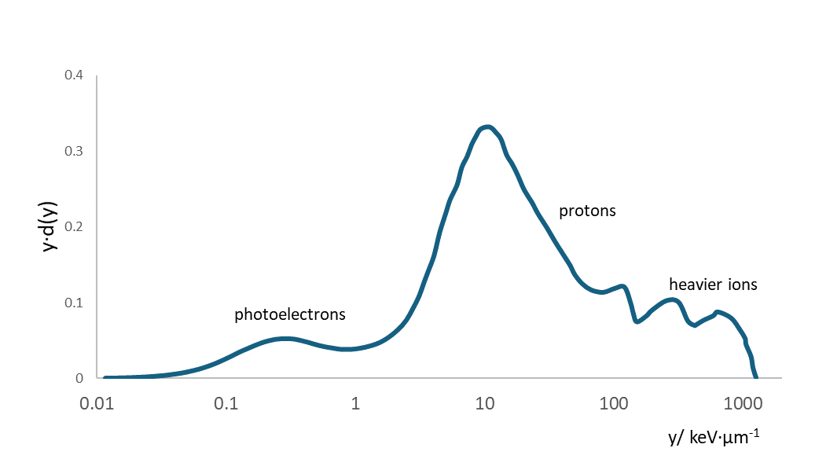

***Figure 1***: Illustrative representation of a lineal-energy spectrum for a mixed photon-neutron field (neutron energy of a few MeV), measured with a spherical microdosimeter simulating 1 µm of tissue. For actual experimental data, refer, for instance, to ICRU Report 98, Figure 6.1 (not reproduced here due to copyright restrictions).

1. **Stochasticity and Charged Ionizing Radiation**

As discussed in the previous section, for indirectly ionizing radiation (e.g., photons and neutrons), the energy imparted to a micrometric site result entirely from random processes. Consequently, microdosimetric spectra in such fields fully reflect the stochastic nature of energy deposition. This historical context has contributed to a strong lexical and conceptual association between microdosimetry and stochasticity, an association that persists even in the context of directly ionizing particles, such as those used in ion-beam therapy.

In ion-beam therapy, a critical reassessment is necessary. Here, stochastic and non-stochastic elements coexist, and their contributions must be carefully disentangled [see Kellerer 1972].

**Mixed contributions in microdosimetric spectra**

To illustrate this dual nature, consider the experimental microdosimetric characterization of a monoenergetic carbon-ion beam, as performed at MedAustron. Figure 2 presents a lineal-energy frequency spectrum collected using a silicon microdosimeter in a 118 MeV/u carbon-ion beam. Several key features of the spectrum highlight both stochastic and non-stochastic components:

A: Unrestricted LET

The value of the unrestricted LET indicated by point A, is a non-stochastic quantity. It can be derived indirectly from the Gaussian profile of the spectrum using appropriate transformations.

B: Peak Lineal Energy

The peak value of the distribution (point B), as well as other statistical descriptors such as the means, are also non-stochastic. These values are commonly used in comparisons between microdosimetric means (ȳD and ȳF) and LET-based metrics (LETd and LETt), as documented across various beamlines and institutions.

C: FWHM of the Gaussian Profile

The full width at half maximum (FWHM) of the Gaussian curve (interval C) **reflects the stochastic nature of energy deposition events**. It captures the variability in energy transfer due to the probabilistic nature of particle interactions and it depends on the site size.

D: Low-Energy Tail from Delta Rays

The rising edge at low lineal energies (interval D) is attributed to delta rays. These events are stochastic in origin and arise from interactions occurring outside the detector.

E: Border Effects

The flat region in the intermediate energy range (interval E) results from border effects of the sensitive volume, where primary particles are only partially interfere. These distortions are site-shape dependent in nature and, while they can be corrected through post-processing, they are not related to stochasticity. The spectrum represented in figure 2 can be considered as the convolution of the spectrum obtained with a border-distortion-free detector and the chord length distribution in a volume which takes into consideration the effects on the border (this topic is discussed in details in another chapter). Reversing the process, the spectrum free from border distortions can be obtained by deconvolution, of the experimental spectrum (as the one represented in figure 2) and the chord length distribution of the sensitive volume which includes border effects.

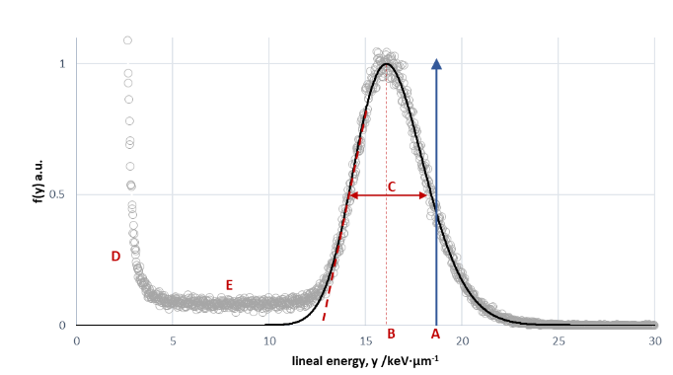

***Figure 2***: Lineal-energy frequency spectrum f(y) collected with a silicon microdosimeter in a 118 MeV/u carbon-ion beam (open circles). The spectrum is normalized to a unit peak maximum. A Gaussian curve interpolates the peak region. A: Unrestricted LET (blue arrow); B: Peak lineal energy; C: FWHM of the Gaussian; D: Delta-ray contributions; E: Border-effect distortions.

1. **Clinical irradiation**

While monoenergetic beams offer a controlled environment for analysis, clinical ion-beam therapy involves more complex scenarios. Figure 3 refers to the irradiation of a simplified target. In the voxels of the target the radiation is given by the combination of particles stopping in that voxel plus particles stopping in deeper voxels. Since also the transversal distribution of intensity is not uniform at the same depth, the characteristic of the radiation varies from voxels to voxel.

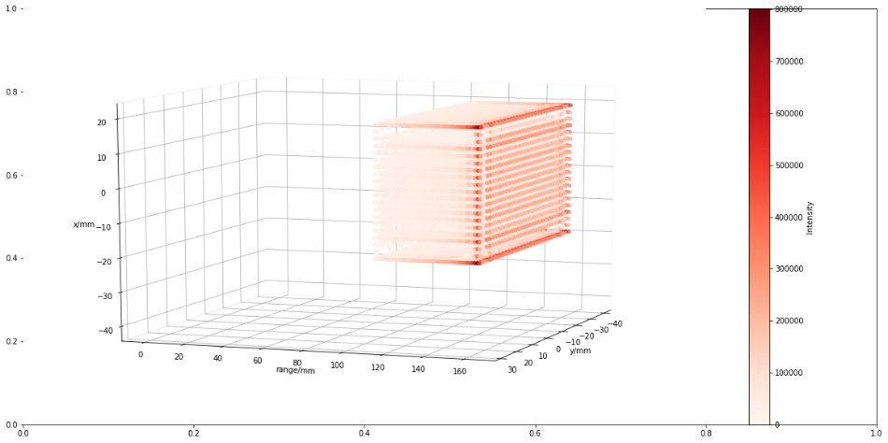

***Figure 3***. Representation of a simple plan in water for the irradiation of voxels in a parallelepiped target. The beams enter horizontally from left to right. The color transparency decreases with the increase of the number of primary particles stopping in that voxel.

Figure 4 refers to a voxel chosen from plan described in figure 3, at 10 millimeters from the distal depth and at the center of the transversal area. The intensities of the different beams impinging in the voxel are represented as function of the electronic stopping power values. The representation is based on the ideal condition of absence of energy straggling so that, the beam remains monoenergetic also after penetrating the target. Under that condition, the LET distribution is represented by the simply as the series of distinct LET values (red lines in the figure 3) each corresponding to the monoenergetic beams. In a realistic scenario, the energy straggling and the presence of ripple filters in the beamline would spread the energy so that, instead of discrete LET values, a more uniform distribution would appear.

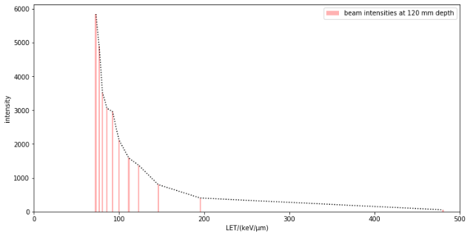

***Figure 4***. Representation of the beam intensities as function of the ideal discrete unrestricted LET values in a voxel at the center of the cross-sectional area at depth in water of 120 mm, 10 mm before the distal edge of the irradiated volume. The dashes black line is used as a guide for the eye between values. The irradiation plan from which the data are extracted is represented in figure 3.

Figure 5 shows the comparison of the experimental spectrum (black line) collected in the position corresponding to the selected voxel of the plan represented in figure 3 with the computed probability-density frequency distribution in lineal energy (continuous red line). The latter is the envelop of the quasi-Gaussian curves (dashed lines in multiple colors) which are calculated using the method of multiple convolution [Kellerer 1968, Magrin 2022] for each beam entering the specific voxel, considered as monoenergetic.

The fact that the quasi-Gaussian curves in figure 5 substitute the single values represented in figure 4 is the direct representation of the co-existence of stochastic and non-stochastic nature of the radiation interaction as discussed above and represented in figure 3. It is worth noting a difference in the that the positions of the values in Figure 4 do not correspond to the mean values derived from the quasi-Gaussian distributions shown in Figure 5. This discrepancy arises because the formers are based on the energy lost, which is systematically higher than the imparted energy on which the latter are based.

This computation ignores the influence of the ripple filters, which in clinics are used to slightly modulate the monoenergetic energy resulting in a millimetric spread out Bragg peak. The effect of the ripple filters on the spectra would be to spread the lineal energy to higher values and, consequently, make the envelop more uniform particularly the highest lineal energies. The effect of ripple filters is predetermined and non-stochastic.

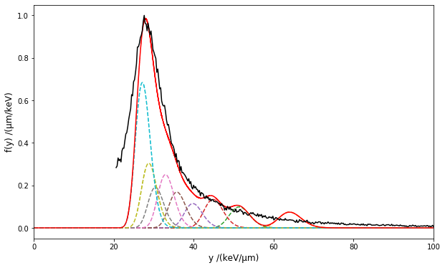

***Figure 5***. Experimental microdosimetric spectrum (black line) representing the frequency distribution in lineal energy, f(y); the spectrum is truncated to exclude the part below 20 keV·µm-1. The quasi-Gaussian curves (dashed lines in multiple colors) are the lineal energy distributions calculated for each distinctive monoenergetic beam entering the voxel represented in figure 3. The envelope of the contributions of all quasi-Gaussian curves is represented with the continuous red line. The normalizations are done to have unitary maxima of the experimental and envelope curves.

In conclusion, the microdosimetric spectra collected in conditions which are realistically representing the clinical irradiation are the result of both stochastic and non-stochastic contributions. The comparison of figures 4 and 5, the first being a complete non-stochastic characterization the second being a combination of stochastic and non-stochastic characteristics, is a guide to the discussion on what is the most clinically relevant.

**Stochasticity in today’s uses**

The attention is directed here toward concepts that incorporate spectral information on radiation quality.

Possibly the most relevant in clinics is the Microdosimetric Kinetic Model (MKM), in which the biological effectiveness is derived using the saturation-corrected dose-mean lineal energy, y*.

$$y^{*}=\int_{0}^{∞}{ y f\left(y\right)·w(y,y_{0})ⅆy}$$

where the saturation weighting function *w(y,y0)*, which depends on an experimentally determined parameter y0 = 150 keV µm−1 , is reported hereafter for completeness:

$$w\left(y,y_{0}\right)=\frac{y_{0}^{2}·\left[1-e^{-{\left(\frac{y}{y_{0}}\right)}^{2}}\right]y}{\int_{0}^{∞}{y·f\left(y\right)ⅆy}} .$$

Without going in a thorough analysis, the effect of the integral and the weighting function is to decrease the relevance of small variation on the spectra as those related to the FWHM shown in figure 2. Therefore, it can be stated (and it is not difficult to prove with numerical examples) that the presence of sequences quasi-Gaussian distributions, as opposed to discrete values of energy imparted per unit of length, has a marginal impact on the resulting value of y*. This assumption is particularly important in clinical uses where the irradiation with multiple beam energies concur in the same tumor target. In other terms, the stochasticity has little or no effects on the final biological effectiveness determined by the MKM.

Microdosimetric spectra have also been employed to derive RBE values through the application of biological weighting function [Loncol 1994, Parisi 2020]. These functions, referred to as biological weighting functions, are purely phenomenological and are obtained by unfolding combinations of radiobiological and microdosimetric experimental data for a large variety of particle types and energies types.

Detectors of different in sensitive-volume size and shape produce large discrepancies in microdosimetric spectra. However, the calibration procedures assure that the frequency mean values coincide, independently from the geometrical differences.

The biological predictions obtained with the use of the weighting functions for monoenergetic beams does not show deviations arising from the use of different detectors [Parisi 2020]. This can be seen as the implicit indication that, in monoenergetic beams, the mean values of the lineal energy are sufficient to answer for the simple biological response.

Finally, in recent years, clinical data have emerged indicating that an increase LETd in the entire target volume correlates with an increased probability of tumor control [Hagiwara 2019; Matsumoto 2020; Molinelli 2020]. It is important to note that, since the clinical effectiveness is based of LET (more precisely, its simplified form LETd), only non-stochastic parameters are considered. In the same direction goes the methodologies of LET painting and simultaneous optimization of dose and LET [Trilemma 2022]. Although the use of LETd could be considered as an oversimplification dictated by the unavailability of more sophisticated data, the general deduction is that the stochasticity of energy deposition events plays a limited role, at least as first order of approximation.

**The role of stochastic contributions in ion-beam therapy**

A critical perspective may argue that the limited relevance attributed to stochastic effects in ion-beam therapy stems from the early-stage methodologies currently used, which may overlook significant stochastic contributions. It is therefore important to highlight several mechanisms, rooted in the stochastic nature of radiation interactions, that could meaningfully influence microdosimetric measurements and should be considered in ongoing discussions.

*i. Pre-Detector Interactions*

Several stochastic effects occur before the radiation reaches the sensitive volume of the microdosimeter:

Energy Straggling: As ions traverse tissue, they undergo numerous stochastic collisions, leading to energy straggling. This results in an increasing energy spread, even for initially monoenergetic beams. The effect is more pronounced for protons due to their lower mass and higher scattering probability, and less significant for heavier ions like carbon.

Nuclear Fragmentation: Primary ions may undergo stochastic nuclear fragmentation, producing secondary fragments with different trajectories and ionization patterns. These fragments contribute increasingly to the microdosimetric spectrum up to the Bragg peak. For carbon ions, this is evident at the fragmentation tail in the distal part of the Bragg curve.

Target Recoil Events: Recent studies (e.g., Gabriele Parisi) have shown that in low-energy proton irradiation, nuclear collisions can displace target atoms, producing localized high-LET events. Although rare, such events contribute stochastically to the spectrum and their biological significance should be assessed.

Delta Rays: As discussed in relation to Figure 2, delta electrons generated outside the sensitive volume can enter it, contributing to the low-energy tail of the microdosimetric spectrum. These contributions are inherently stochastic and contribute to a significant percentage of the absorbed dose.

*ii. Site Size Effects*

At nanometric or sub-cellular scales, the stochasticity of energy deposition becomes increasingly relevant. When site sizes are on the order of nanometers, the randomness of interaction points dominates, and the average distance between ionizations loses biological meaning. This is the domain of nanodosimetry.

*iii. Multiple Events*

At clinically relevant doses, the likelihood of multiple radiation events occurring within a single cell nucleus is high (described as point (c) in the section 2). This raises an ongoing debate about whether single-event metrics (e.g., lineal energy) are sufficient, or whether multiple-event distributions should be considered instead. This is perhaps the strongest argument for incorporating stochastic analysis into the assessment of radiation quality in ion-beam therapy. Addressing this point requires a critical analysis more general than the one carried out here, focusing on changing current universal clinical characterization of the radiation quality in terms of energy deposition from single events.

1. **Significance of Stochastic Nature in LET**

Although LET (Linear Energy Transfer) is a deterministic quantity, it arises from inherently stochastic interactions between charged particles and the electrons of the traversed medium. Clarifying this relationship is both insightful and essential for a deeper understanding of energy deposition processes.

A foundational perspective on this topic was introduced by Rossi [Rossi, 1968], who illustrated how the distribution of energy transferred to electrons varies significantly with the mass of the target volume. His original figure, based on ions with energies of a few MeV, intuitively demonstrated how increasing the size of the sensitive volume reduces the variability in energy deposition.

Figure 6 presents an updated version of Rossi’s concept, adapted for ion energies in the hundreds of MeV—typical of clinical radiation fields. The energy-loss distributions shown are generated by recursively convolving the single-collision energy-loss spectrum, as detailed in the Python code provided in the appendix.

At these high energies, a small number of secondary electrons (delta rays) can acquire substantial energy, traveling hundreds of micrometers from the primary ionization site. Additionally, their trajectories are irregular.

In figure 6, to ensure inclusion of delta rays, cylindrical volumes with constant cross-sectional area and increasing thickness are considered; the energy loss per unit of length—whose average corresponds to the unrestricted LET—is represented as function of target thickness. As thickness increases, the distributions narrow, and around 1 mm, they converge to a stable value, representing the unrestricted LET.

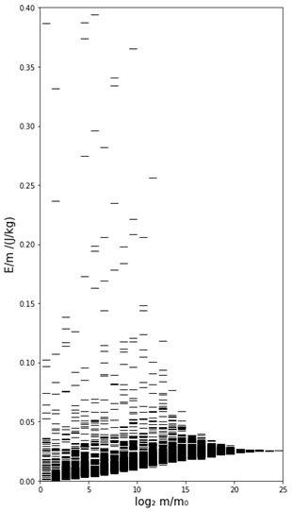

Figure 6. Illustration of the stochastic nature of energy loss by single particles of identical energies traversing targets of varying mass. The density of lines provides a qualitative representation of the probability of events of energy loss per unit mass and then, an indirect indication of the distribution spread. As the target mass increases from left to right, the distribution narrows, indicating reduced variability and convergence toward a nearly constant value of energy per unit of mass. The figure is inspired by Rossi’s illustration [Rossi 1968] often used to illustrate the stochastic nature of energy deposition in targets of different masses.

1. **References**

[Brenner 1998] Brenner DJ, Zaider M., Letters to the editor: Estimating RBEs at clinical doses from microdosimetric spectra. Medical Physics. 1998; 25(6):1055-7.

[Inaniwa 2010] Inaniwa T, Furukawa T, Kase Y, Matsufuji N, Toshito T, Matsumoto Y, et al., Treatment planning for a scanned carbon beam with a modified microdosimetric kinetic model. Phys Med Biol 2010;55:6721–37. <https://doi.org/10.1088/0031-9155/55/22/008>

[Hagiwara 2019] Hagiwara Y, Bhattacharyya T, Matsufuji N, et al. Influence of dose-averaged linear energy transfer on tumour control after carbon-ion radiation therapy for pancreatic cancer. Clin Transl Radiat Oncol 2019;21:19–24. <https://doi.org/10.1016/j.ctro.2019.11.002>.

[Hawkins 1994] Hawkins R. A statistical theory of cell killing by radiation of varying linear energy transfer. Radiat Res 1994;140:366–74. https://doi.org/10.2307/3579114.

[Kellerer 1972] Kellerer AM. An algorithm for LET-analysis. Physics in Medicine & Biology. 1972 Mar 1;17(2):232.

[Kellerer 1985] Kellerer AM, Fundamentals of microdosimetry, Chapter in ‘The dosimetry of ionizing radiation: Volume I’, Kase KR, Bjärngard BE, Attix FH Editors, Academic Press, Inc. Harcourt Brace Jovanovich, Publishers, 1985

[Loncol 1994] Loncol T, Cosgrove V, Denis JM, Gueulette J, Mazal A, Menzel HG, Pihet P, Sabattier R. Radiobiological effectiveness of radiation beams with broad LET spectra: microdosimetric analysis using biological weighting functions. Radiation Protection Dosimetry. 1994 Apr 1;52(1-4):347-52., <https://doi.org/10.1093/oxfordjournals.rpd.a082212>

[Magrin 2018] Magrin G. A method to convert spectra from slab microdosimeters in therapeutic ion-beams to the spectra referring to microdosimeters of different shapes and material. Physics in Medicine & Biology. 2018 Oct 29;63(21):215021.

[Matsumoto 2020] Matsumoto S, Lee SH, Imai R, et al. Unresectable chondrosarcomas treated with carbon ion radiotherapy: relationship between dose-averaged linear energy transfer and local recurrence. Anticancer Res 2020;40:6429–35. <https://doi.org/10.21873/anticanres.14664>.

[Molinelli 2021] Molinelli S, Magro G, Mairani A, et al. How LEM-based RBE and dose-averaged LET affected clinical outcomes of sacral chordoma patients treated with carbon ion radiotherapy. Radiother Oncol 2021;163:209–14. https://doi.org/10.1016/j.radonc.2021.08.024.

[Parisi 2020] Parisi A, Sato T, Matsuya Y, Kase Y, Magrin G, Verona C, Tran L, Rosenfeld A, Bianchi A, Olko P, Struelens L. Development of a new microdosimetric biological weighting function for the RBE10 assessment in case of the V79 cell line exposed to ions from 1H to 238U. Physics in Medicine & Biology. 2020 Dec 2;65(23):235010.

[Pihet 1999] Pihet P, Menzel HG, Letters to the editor: Response to the Letter to the Editor “Estimating RBEs at clinical doses from microdosimetric spectra”, Medical Physics. 1999; 26(5):848-52

[Rossi 1968] Rossi HH. Microscopic energy distribution in irradiated matter. Radiation dosimetry. 1968 Jan 1;1:43-92.

1. **Source files**

Figure 6: [Source: Python notebook — Energy_straggling_convolutions-FFT-14Feb2025-Rossi_graph.ipynb]

|  |  |  |  |
| --- | --- | --- | --- |
| Chapter GREEN | | | |
| **Version** | **Date** | **Authors** | **Major changes and comments** |
| 0.1 | 28 July 2025 | Giulio Magrin | First version |
|  |  |  |  |
|  |  |  |  |
|  |  |  |  |