Prerequisites for LET measurements
(Authorships and version dates are indicated in the table at the end of the document)

Introduction

It is important to underscore a few general concepts which help understanding the nature of linear energy transfer (LET) and the procedures for applying it in the framework of the therapeutical ion beams.
One of the main objectives of this work is to establish the relationship between measurable quantities, which are inherently affected by the stochastic nature of energy-deposition processes, and LET, which is a deterministic quantity associated with the radiation field. Achieving this goal first requires a clear definition of the specific LET quantity of interest. This task is complicated by the fact that the term LET is used to describe a range of related quantities, each based on different averaging procedures and often represented in different ways within the literature.
A large part of the chapter characterizes the ionizations coming either from collisions of the primary ions or secondary electrons. Emphasis is put, at first, on distinguishing the concepts of unrestricted and restricted LET and on the implementation of measurements linked to LET.
A note about notations: Originally, LET was used as an abbreviation, while the symbol representing the quantity and its associated formulas traditionally employed the notation L. In recent years, however, the use of LET has increasingly appeared directly within formulas and is now encountered regularly in the radiation therapy and dosimetry literature. Despite this trend, the original notation of L is still retained in recent ICRU reports, and this document adopts the same convention for the sake of consistency with established metrological standards and radiation units.
- Context and background
LET accounts for energy transferred by ionizing particles to the electrons of the medium. Three categories of charged particles may ionize the medium: primary ions, secondary electrons, and nuclear fragments.
The energy transferred is assumed to be proportional to the number of ionizations generated. The W-value, which expresses the mean energy required to create a pair ion/electron (or hole/electron) may vary noticeably with the projectile ion’s energy and type but is approximated, in this discussion, to be constant, independently on the characteristics of the charged particles. The W_-value is then considered as the constant which converts the number of ionizations measured to the energy exchanged. In the matter crossed by the radiation before the site of interest, nuclear interactions produce a non-negligible contribution of nuclear fragments which increase with the penetration depth; however, these contributions are not considered in the present study, which focuses exclusively on primary ions and secondary electrons
Track structure, in ionizing radiation, refers to the spatial distribution of energy deposition events as charged particles traverse a medium. It represents the stochastic pattern of ionizations and excitations created by the passage of the ion, which is very heterogeneous. Biological effects are related to the pattern of the energy lost along the track; several biological models estimate cell lesions and death in relation to the spatial distance between multiple ionizations. Geometrically speaking, the track structure is the result of two different patterns of ionizations due to primary ions and secondary electrons. The ionizations from primary particles occur within a few nanometers from the track. Instead, the secondary electrons have very variable ranges and are emitted with various angles; the ionizations, although concentrated around the track, may occur hundreds of micrometers away. In the core of the track, the ionizations are dense and are caused by primary particles and low-energy secondary electrons. In the penumbra, at the periphery, the ionizations are caused exclusively by the secondary electrons of higher energy (delta rays).
Estimating unrestricted LET requires addressing the complexity of particle track structures. While computational approaches are feasible, experimental assessments using detectors present significant challenges, particularly due to their limited cross-sectional area. When the primary particle traverses the detector’s volume, some delta rays may escape, and, in that case, the measurement cannot relate to unrestricted LET. For further considerations about the maximum energy of delta rays produced in the collisions, see Chapter “red” on definitions.
A proper estimation of energy lost and consequently of unrestricted LET can be achieved by assessing the energy of the primary particle immediately before and after traversing the target. However, experimental setups for such measurements are highly complex, and careful considerations are required to ensure that any energy loss unrelated to electronic collisions is negligible.
An imperfect correlation between restricted LET and the detector measurements can be done keeping in mind that, for LET, the cut-offs of contributions are specified by the delta-ray energy while, for detectors, they are determined by the geometrical limits of their sensitive volumes.
If the primary particle passes just outside the sensitive volume, the detector captures some delta rays produced, which, in this document, are referred to as delta rays “detected in non-coincidence with primary ions” or simply “non-coincident delta rays”. In the computation of the LET they contribute as independent events of energy deposition. The relative number of delta rays escaping or entering the sensitive volume is the parameter to study when indicating whether the LET measured is restricted or unrestricted.
- Conceptual variants of LET distributions in the literature
The term “LET distribution” is used in several conceptually distinct ways across radiation and medical physics. To place the present work within a consistent framework and avoid ambiguity, we outline three common interpretations and the relationships among them represented in figure 1.
  - Three distinct interpretations
First, the full energy-loss distribution for particles of identical type, energy, and direction characterizes the stochastic spread of energy lost in electronic collisions while traversing a material over an infinitesimal path length. “Full” indicates that all energy carried by delta rays is included without any energy cutoffs. The unrestricted linear energy transfer, LET​, is obtained as the expectation value of the energy loss per unit path length from this distribution, with no delta-ray energy restriction. This averaging represents the transition from the stochastic framework of the random collisions to the non-stochastic domain represented by the unrestricted LET so that, particles with given type and energy are associated with a unique unrestricted LET value. In the Green chapter, examples of energy-loss distributions are presented and discussed. As the reference thickness increases from the nanometer to the micrometer scale, the shape of the distribution evolves accordingly, transitioning from an asymptotic form to the characteristic Landau profile shown in figure 1, left.
Second, the density distribution of LET values within an irradiated volume reflects the heterogeneity of the mixed radiation field incident on that volume and has lost any dependence on the stochastic nature of single interactions. In clinical irradiation, this distribution arises from the combined contributions of particles with different types, directions, and energies as a result of the incident beam characteristics as well as energy-loss straggling and secondary particle production upstream the detector. LET density distributions can be expressed either as frequency function, f(L), or as dose function, d(L). These representations are used to derive the track-averaged LET (L̄_{T}​) and the dose-averaged LET (L̄_{D}), respectively, using the known equations:
 | $${\overline{L}}_{T}=\int_{0}^{∞}{L f(L)}dL$$  $${\overline{L}}_{D}=\int_{0}^{∞}{L d\left(L\right)}dL=\frac{1}{{\overline{L}}_{T}}\int_{0}^{∞}{L^{2} f\left(L\right)}dL$$ | (Eq. 1)

Third, the spatial distribution of L̄_{D} represents the voxel-wise mapping most commonly used in treatment planning. In each voxel, L̄_{D} is derived from the local dose-density LET distribution described above, resulting in a non-stochastic field of L̄_{D} ​ values defined over the target in a discretized three-dimensional grid. Because the voxel dimensions are on the millimeter scale, substantially larger than the microscopic volume over which L̄_{D} ​ is inherently defined, the resulting voxel-level values should be interpreted as averages of multiple microscopic contributions within that volume. A more appropriate notation would therefore be ⟨L̄_{D}⟩, where the overbar denotes averaging over the LET dose distribution L̄_{D}, and the angle brackets ⟨⋅⟩ indicate the subsequent averaging over all sub regions, weighted proportionally to the dose of events of energy depositions occurring in each sub-region.
In this paper, we focus separately on (i) the energy-loss distribution described in the first interpretation and (ii) the density distribution of LET within the target, described in the second interpretation. In section 6 devoted to the analysis of Monte Carlo computation, we discuss how missing recognizing the distinction between stochastic and non-stochastic roles may lead to improper results.
  - Practical suggestions for reproducibility and clarity
Unrestricted versus restricted LET must be stated explicitly. If any delta-ray energy cutoff is applied in scoring, the result is a restricted LET, L_{rest,} where rest indicates the maximum energy of the secondary electrons taken into consideration. When reporting L̄_{T} or L̄_{D}, we should specify whether they are formed considering restrictions and, in case, indicate the cutoff value.
- Energy characterization of ionizations
Relying on the Bethe–Bloch equation, one can distinguish ionizations caused directly by interactions between primary ions and the medium’s electrons from those resulting from subsequent collisions of secondary electrons. The approximate number of primary collisions can be inferred from the minimum and maximum impact parameters defined in the theory [Bethe 1930].
  - Primary and secondary ionizations
The angles between the primary-ion track and the beam axis are within a few degrees so that in first approximation, the trajectories can be considered parallel among each other and perpendicular to the frontal face of a plane-parallel detector. The number of primary collisions which generate secondary electrons is given by the product of the target’s electron density, n_{e}, and the volume where the interactions are taking place. This is a cylindrical region around the track with a radius assumed to be coincident to the maximum impact parameter, b_{max}, defined as the maximum distance of interaction between the ion and the electron of the medium, assessed by the formula:
 | $$b_{max}=\frac{1}{4πε_{0}}\frac{ze^{2}}{βc}\sqrt{\frac{2}{m_{e}I}}$$ | (Eq. 2)
where ε₀ is the vacuum permittivity, z is the atomic number of the ion, c is the speed of light, βc is the particle velocity, m_{e} is the electron mass and I is the mean excitation energy of the medium. Although Bethe’s formulation also introduces a minimum impact parameter b_{min}, this does not influence present calculation. This method to estimate the number of primary interactions remains applicable down to primary particle energies of a few MeV·u⁻¹. At lower energies, electron capture becomes significant and suppresses the production of free charges.
For all the ions used in therapy, b_{max} is limited to not more than a few hundred picometers around the primary particle track. For instance, for 400 MeV·u-¹ carbon ions in silicon, the maximum impact parameter is 23 pm while, for 1 MeV·u-¹, it is 350 pm. Similarly, for 250MeV protons, b_{max} is 2.8 pm, while for 1 MeV, it is 17 pm.
For a path of the primary particle of length dx, the volume of interaction is then π(b_{max})²dx. The electron density n_{e} is given by:
 | $$n_{e}=N_{A}ρ\frac{Z}{M}$$ | (Eq. 3)
where N_{A} is the Avogadro's number (6.022·10²³ atoms·mole⁻¹), and ρ, Z, and M are density, atomic number, and atomic molar mass respectively. For a silicon target, the corresponding values are ρ = 2.32 g·cm⁻³, Z = 1, M = 28.09 g/mole so, from Eq. 2 n_{e} = 6.96·10²³ cm⁻³.
The number of electronic collisions of the primary particles per micrometer calculated for the example before, corresponds to N_{p} = 1157.
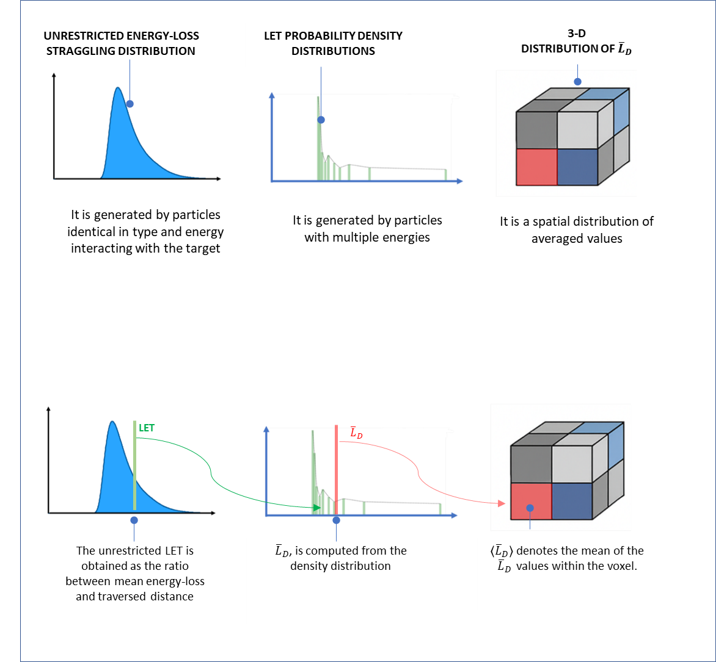
Conversely, the total average number of electrons generated per unit of length, N_{t}, is given by the electronic stopping power divided by the W-value. In the example, for 400 MeV·u⁻¹ carbon ions, with electronic stopping power (in the silicon target of density 2.32 g·cm³) of 20.7 keV·µm⁻¹, and the W-value of 3.62 eV, the total number of electrons generated per micrometer is then N_{t} = 5729.
Finally, the number of electrons generated by secondary electrons, N_{s} is simply the difference N_{t} - N_{p}; then in the previous example this is N_{s} = 4572.
The ratio between the electrons produced by secondary and primary collisions increases continuously with the energy of the primary particle. For low-energy ion beams of approximately 1 MeV·u⁻¹, most ionizations are produced by primary ions. This can be explained considering that the energy of the secondary electrons is, on average, lower than the W-value and therefore the probability of a secondary ionization is low (see figure 3).

Figure 1: (a) Schematic representation illustrating how three distinct concepts are commonly associated with the term LET distribution. From the three distributions, three LET related values are obtained: (b left) the unrestricted LET of monoenergetic beams as expectation value of energy‑loss distribution per unit of length; (b center); the dose‑averaged LET, L̄_{D}, is derived from the corresponding probability density distribution; (b right) the voxel-averaged < L̄_{D} > visualized in the spatial distribution. 3 LET distributions.pptx
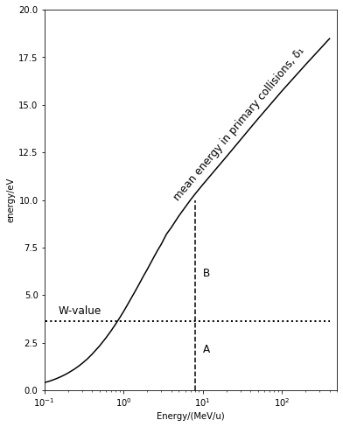
Figure 3. Mean energy lost by a primary carbon ion through Coulomb collisions with electrons in a silicon target. For comparison, the W‑value is also shown. Above 1 MeV·u⁻¹, the lengths of segments A and B provide an approximate indication of the energy deposited in the first collision of the ion and in the subsequent collisions of the secondary electrons, respectively.
Already at beam energies of a few MeV·u⁻¹, the mean energy lost is sufficient to produce more free ions from the collisions of the secondary electrons (segment B in Figure 3) than those to the primary ions (segment A in Figure 3).
For higher beam energies, the increase of the relative number of secondary collisions is less drastic so that, at the maximum carbon-ion energy used in clinics, the number of electrons freed in secondary collisions is approximately four times that in the primary ionizations. It should be noted that, as the beam energy increases, the absolute number of collisions decreases significantly, as illustrated in Figure 4.
- Distance of ionizations from the particle track
Using a representation based on the unrestricted LET implies that all ionizations which result from the crossing of the primary charge particle are accounted, irrespective of their distance from the primary particle track. These distances span a broad

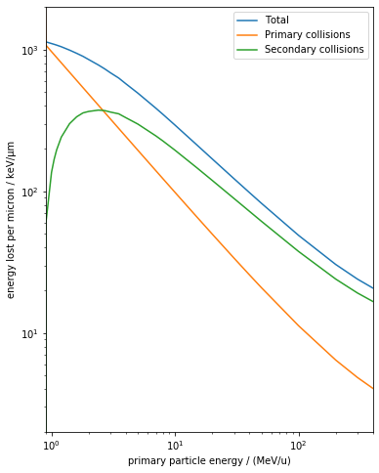
Figure 4. Mean energy lost per micron of silicon (density 2.32 g·cm⁻³) by carbon ions in primary and secondary collisions as function of the ion energy.
range. At clinical energies, the range of most secondary electrons generated is less than a few nanometers; however, a small fraction of electrons can acquire sufficient energy to travel some millimeters away from their point of origin.
Let’s analyze separately the energetic characteristics and patterns of the ionizations produced by primary and secondary particles in relation to the distance from the tracks and to the consequential impact of the different detection systems.
  - Ionizations induced by secondary electrons
We have seen that the energies transferred to secondary electrons during collisions span several orders of magnitude. The most probable interactions involve energy exchanges of only a few electronvolts, resulting in ionizations occurring within a few nanometers of the primary particle track. The probability of collisions decreases constantly with the increase of the transferred energies. Only a very small fraction of secondary electrons acquires the highest energies, leading to rare ionizations as far as millimeters from the original interaction site. Quantifying those contributions is essential for understanding how energy deposition scales with the size of the sensitive volume under consideration, in particular detectors’ sensitive volumes and biological targets.

Geometrical characterizations start from considerations on relativistic kinematics transferable energy to an electron by the incoming primary particle. The maximum collision energy, є_{max}, of the secondary electron of rest mass m_{e} for a primary particle of mass M_{i}, and Lorentz factor γ is determined by the equation:
$$є_{max}=\frac{2m_{e}β^{2}γ^{2}}{1+2γ{m_{e}}/{M_{i}}+{\left({m_{e}}/{M_{i}}\right)}^{2}}$$
(Eq. 4)
This equation quantitatively defines the upper bound of the secondary electron energy spectrum and therefore constrains the maximum distance over which these rare, high‑energy electrons may induce ionizations. As the energy of the primary particles decreases, both the maximum transferable energy and the corresponding maximum range of secondary electrons decrease accordingly.
The maximum lateral extension of delta electrons is determined by the continuous slowing down approximation (CSDA) range of electrons with energy e_{max}, which, in turn, is derived from the relativistic expression for the maximum energy transferable in a single collision in Eq. 4. CSDA ranges can be obtained from the reference datasets provided by NIST or the ICRU [Berger 1982; ICRU-37 1984; ICRU-49 1993].
For example, for carbon ions at 400 MeV·u⁻¹, which is the highest energy used clinically at MedAustron, the maximum delta electron energy in water, computed using Eq. 4, is 1.06 MeV. The corresponding CSDA range exceeds 5 mm. For 250 MeV protons, e_{max} is 616 keV with an associated range of approximately 3 mm. At much lower primary-particle energies, such as 1 MeV·u⁻¹ for carbon ions or 1 MeV for protons, the maximum delta electron energy drops to approximately 2 keV, corresponding to a range of about 220 nm. Because NIST tables provide electron range data only above 10 keV, this lower-energy estimate is obtained instead using Wilson’s Excel based tool [Wilson 2018].
It is worth emphasizing that, due to the tortuous nature of electron trajectories, the CSDA range overestimates the actual transverse displacement of delta electrons from the primary track. More realistic estimates could be obtained using the projected range, which provides net displacement along the initial direction of motion. However, projected ranges are not routinely tabulated in standard datasets and would require dedicated Monte Carlo simulations. Codes such as CASINO and PENELOPE, which are openly available, can be used for this purpose and provide more accurate modeling of low energy electron transport.
  - The challenge on LET of penumbra ionizations
To summarize, the primary ionizations, together with those produced by low‑energy secondary electrons, occur within nanometric distances from the ion trajectory and can therefore be regarded as forming a strait sequence of ionizations along the track core. In contrast, higher‑energy secondary electrons may induce ionizations at much larger radial distances, in some cases extending to millimeter scales.

When the unrestricted LET is used, ionizations generated by both primary ions and delta rays are indistinguishably combined, without accounting for their spatial distribution around the track. This could lead to the consequence that two types of charged particles which exhibit the same unrestricted LET may have markedly different transverse ionization densities and, in turn, distinct biological effects.

For example, the unrestricted linear energy transfer L∞ in water for two ion beams, 18.5 MeV·u⁻¹ helium and 400 MeV·u⁻¹ carbon, is identical (11 keV/µm). However, the corresponding ratios between primary and secondary ionization densities differ significantly, with values of 0.67 and 0.37, respectively. Such discrepancies in the ionization patterns inevitably influence the physical response of the detection system.

This raises a natural question when dealing with micrometric targets, such as a typical mammalian cell nucleus: Why should the biological response of such a small site be correlated with a physical descriptor –the unrestricted LET- that includes contributions from electrons escaping far beyond the site and thus not contributing to local energy deposition? We discuss this choice and provide motivation in Section 3.5.
A reasonable alternative would be to adopt as descriptor the restricted LET, which includes only the contribution of secondary electrons below a selected cutoff energy and therefore confines energy deposition considered only to the immediate vicinity of the collision point. For example, L₁₀₀ includes only secondary electrons with energies up to 100 eV, corresponding to ranges in water of approximately 1 nm. Despite the conceptual advantages of restricted LET for micro- and nano-scale considerations, it has been only rarely applied in the characterization of clinical ion beams.

  - Representation of unrestricted LET

Some authors underestimate the difference between unrestricted and restricted LET as reported in the comprehensive survey of Kalholm et al. [Kalholm 2021]. These differences, which increase progressively with the increase of energy of clinical ion beams, have important consequences on the biological effects.

This is possibly due because of the low values of the collision distribution ω(є), which represents the probability distribution of delta-ray energy after the collision of the primary particle. The distribution ω(є), following Rutherford scattering theory and, for energies above a few tens of electronvolts, has an inverse dependence over the square value of the energy є:
 | ω(є) ∝ 1/є² | (Eq. 5)

The rapid asymptotic approach to the horizontal axis of ω(є) is shown in Figure 5, and may have led to the erroneous assumption that, for the highest values of є, the contribution of ω(є) may be ignored.

At the contrary, the correct assessment of the average є, and consequently of the unrestricted LET, requires the use of a complete distribution ω(є) as we are showing hereafter.
A different representation of ω(є) proposed by Kellerer can convince us of the importance of assessing delta-ray energy imparted.
The area under the function ω(є) within the interval (є, є + dє) represents the relative number of collisions resulting in secondary electrons with energies in that interval. Analogously, the area under the function є·ω(є) represents the relative energy lost in collisions within that interval. Furthermore, in the semi-logarithmic representation adopted by Kellerer, an additional multiplication factor є is used to maintain the so-called “area rule”. The area rule states that the probability for a certain condition to be satisfied within a specific interval of values (a, b) is proportional to the area under the curve in that interval.

Considering the dependence of ω(є) on є shown in Eq. 5, the resulting representation є²ω(є) is flat for energies є above approximately 100 eV, and until the value є_{max} is reached, see the area Figure 6.

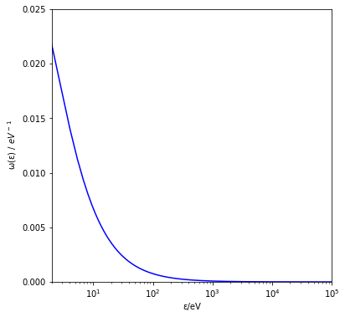
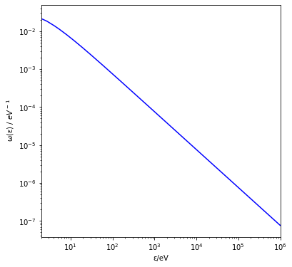

Figure 5. Example of the energy distribution of δ-rays produced in water by carbon ions with an energy of 45 MeV·u⁻¹. Although not clearly apparent in the logarithmic–linear representation (top panel), the logarithmic–logarithmic representation (bottom panel) reveals that the distribution remains non-zero up to energies of several hundred keV, as predicted by Eq. 4.

Kellerer’s representation gives also a clear visualization of the impact of the secondary electrons’ escape whose fraction of the energy lost is not accounted for. In relative terms this expresses also the difference between the unrestricted LET and the restricted LET.
For instance, in the example shown in Figure 6 for 402 MeV·u⁻¹ carbon ions in silicon, the blue area, below 10 keV is approximately 30% smaller than the total area (blue and red areas together). This means that, excluding the values above 10 keV would lead to an estimation of LET_10keV which is 30% lower than the unrestricted LET. This result may be surprising since, the density distribution ω(є) at the energy of 10 keV is already one million time smaller than the value at 10 eV, indicating that a relevant part of the energy lost is due to a rather small number of collisions.

To correlate the cut in delta-ray energy to a cut in size one should consider the threshold in energy for the escaping secondary electrons and calculate the correlated projected range. This distance is an important parameter to be correlated to LET experimental measurements: as mentioned above, only detectors with millimetric sensitive volumes could account for the unrestricted LET of a 402 MeV·u⁻¹ carbon-ion beam and, alternatively, a 20 µm silicon microdosimeter can assess unrestricted LET only in ion beams of energy below 50 MeV·u⁻¹.
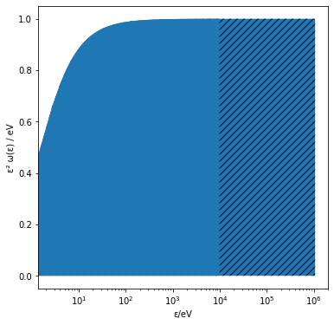
Figure 6. Density distribution of the energy lost in single collisions of 402 MeV/u carbon ions with electrons in the medium. The maximum δ-ray energy is approximately 1 MeV. Multiplication by the factor ε² in the representation ensures the validity of the “area rule” in the semi-logarithmic plot (see text). Accordingly, the blue region represents the total energy transfer, while the hatched region indicates δ rays with energies above the arbitrarily chosen 10 keV cut-off and thus corresponds to the fraction of energy transfer carried away by escaping δ rays.

To correlate the cut in delta-ray energy to a cut in size one should consider the threshold in energy for the escaping secondary electrons and calculate the correlated projected range. This distance is an important parameter to be correlated to LET experimental measurements: as mentioned above, only detectors with millimetric sensitive volumes could account for the unrestricted LET of a 402 MeV·u⁻¹ carbon-ion beam and, alternatively, a 20 µm silicon microdosimeter can assess unrestricted LET only in ion beams of energy below 50 MeV·u⁻¹.
In section 7, we show how the size mentioned above because of the ballistic characteristics of primary ions and secondary electrons is strongly correlated to the sensitive volume transversal cross section and less to its thickness. An analysis of the cross-sectional area of sensitive volumes for several systems claiming to provide LET measurements is done in the following sections. Also, this can be used to define the geometrical thresholds which guarantee that the assessed LET is, indeed, unrestricted.
  - The challenge of a LET cross-calibration
Some authors suggested calibrating active or passive detectors in LET using, as reference, the detector response to a radiation of known (restricted or unrestricted) LET. This procedure can be validated only if two separate conditions are fulfilled. Firstly, two distinct patterns of energy depositions which correspond to the same (unrestricted) LET should provide the same detector readings. Secondly, the calibration must be independent from the beam energy at least for a reasonable interval of values.
Any calibration for unrestricted LET measurement should address the compatibility with contributions from primary and secondary ionizations and the limited interval of operation in terms of particle energy and type.

  - Unrestricted LET as clinical parameter
The biological effects of ionizing radiation correlate with the average spatial separation between ionization events at different structural scales [Palmans 2015]. These scales range from a few nanometers (DNA strand spacing) to sub-micrometers (chromatin loop dimensions), up to several micrometers (cell-nucleus diameter). Because the unrestricted LET quantifies only the average energy lost per unit's path length, it does not provide a unique or direct measure of the ionization-spacing distribution as discussed in Section 4.2. Consequently, if the goal is to establish a mechanistic link between energy deposition patterns and cellular effects, the unrestricted LET is an inherently suboptimal descriptor.
Additionally, the experimental determination of the unrestricted LET is extremely challenging, and in many cases practically impossible with currently available detection technologies.
Some questions therefore arise in particular within the microdosimetry community: why has unrestricted LET been adopted as the primary clinical descriptor of radiation quality, and why is it still considered the reference parameter for future applications? Several considerations support this choice and justify the effort put into measuring it:
- The simulation of unrestricted LET is computationally robust and minimally dependent on subjective modelling decisions. It does not require assumptions on the spatial path of secondary electrons, does not impose thresholds on electron energies, and does not require explicit electron-transport simulations.
- The equivalence between unrestricted LET and the unrestricted electronic stopping power ensures that it is the quantity most directly linked to available experimental data, which, although limited, supports the published electronic stopping-power tables.
- Unrestricted LET varies continuously with particle energy and therefore serves as an effective discriminator between radiation qualities that differ only subtly.
- For monoenergetic ion beams, the spectral determination of L∞ from the energy‑loss distribution (see Figure 1, left) enables, with minimal additional computation, the derivation of restricted LET values at any chosen cutoff. This provides an approximate comparison with microdosimetric spectra [Magrin 2022].
- Finally, unrestricted LET is widely implemented in clinical practice, including recent integrations into carbon-ion therapy treatment-planning systems [Inaniwa 2017, Koto 2024].

In conclusion, completely abandoning unrestricted LET or replacing it with an alternative descriptor is unrealistic, at least in the near term. The more appropriate perspective is to complement unrestricted LET with additional descriptors of radiation quality. These should be systematically evaluated and optimized against biological and clinical outcomes to determine whether they offer a stronger correlation with radiobiological effectiveness. Achieving this requires robust experimental benchmarks, which in turn depend on detectors whose responses must be carefully analyzed and specified with respect to the different characteristics of the track structure.

- Detectors for LET assessment
The response of a dosimeter to ionizing radiation depends on the total energy imparted but is also affected by the local density of the charges produced by the radiation. As a consequence, most dosimetric systems, whether operating in active or passive mode, exhibit readings which are different if, for example, one gray is delivered by 150 kV photons or by 400 MeV·u⁻¹ carbon ions. Although this radiation-quality dependence represents a limitation from the dosimetric standpoint, it can provide indirect information on radiation quality within well-defined intervals of dose and of energy-deposition density.
Exploiting this behavior, the literature frequently reports assessments of radiation quality derived from indirect detector responses and described as “measurements of LET”. Such terminology should be used with caution, especially when the intended reported quantity is the unrestricted LET, which, as discussed above, cannot be measured directly for clinical beams of high energies due to the role played by δ-ray escape. A more appropriate terminology would be a “determination” or “deduction of LET”, as the value is inferred from detector-specific response functions rather than obtained through a direct physical measurement.
The most accurate determination of unrestricted LET requires access to both primary-ion energy loss in electronic interactions and the full spectrum of secondary electrons generated along the track. In practice, no current detector system, whether active or passive, can completely and directly measure this quantity within therapeutic radiation fields, with the exception of complex metrological systems capable of measuring simultaneously and particle-by-particle energy loss and total energy. Instead, different detector classes provide partial or transformed observables, which relate indirectly to a specific LET parameters such as track-averaged LET, dose-averaged LET, or silicon-equivalent or water-equivalent LET spectra.
This subsection provides an overview of common detector systems used in radiation‑quality characterization, with the aim of clarifying LET‑related quantities they actually provide and the limitations inherent to each method. The analysis concentrates on three key aspects: the capability of a detector to provide unrestricted LET, its ability to deliver spectrometric information, and its suitability for deriving track- and dose‑averaged LET.
A detector capable of approaching the direct measurement of unrestricted LET must be able to register both the dense core ionization and the sparse delta‑electron contributions described in Section 2. A direct assessment of unrestricted LET for ions of several hundred MeV·u⁻¹ would therefore require sensitivity to highly infrequent ionization events occurring up to millimetric distances from the primary trajectory.
Conversely, if the transverse dimension of the detector is limited to a few micrometers, direct measurement of unrestricted LET cannot, in principle, be achieved. Under these conditions, the detector is sensitive only to restricted LET. Therefore, any reported LET value should explicitly state the associated cutoff, either in terms of δ-ray energy or the corresponding δ-ray range, to avoid ambiguity in its interpretation.
In radiation environments such as therapeutic ion beams, the problem becomes more tractable. In these cases, the irradiation when it reaches the detector is not entirely unknown: at the entrance, the pristine field is composed of a single particle species, with discrete and well‑defined energy values, and an essentially unidirectional trajectory. Under such controlled conditions, detectors with reduced sensitive dimensions can still give indirect estimates of the unrestricted LET, provided that suitable modeling approaches and auxiliary beam information are incorporated. For example, as discussed in the following sections, certain features of the microdosimetric spectrum can be used to discriminate between monoenergetic ion beams of different energies. With the aid of precomputed reference tables or calibration data, the corresponding electronic stopping power can then be assigned. For primary ions, this quantity is equivalent to the unrestricted LET and can therefore be used as its estimator.
The second aspect concerns the detector’s ability to provide, form non‑monoenergetic beams, a spectrometric response. Spectrometric capability implies that the detector can distinguish the LET associated with individual particle tracks and, consequently, reconstruct the complete LET distribution. Such capability is not limited to active detectors; it can also be achieved with detector systems that record ionization events on a track-by-track basis, such as fluorescent nuclear track detectors and track-etched detectors
For detectors that do not provide a spectrometric response and instead yield a single average value, an additional consideration concerns what is the specific physical quantity represented. Such detectors are often described as measuring either the track-averaged LET or the dose-averaged LET​. However, these assumptions should be critically evaluated also in light of the limitations discussed in the literature [Hajek 2004; Parisi 2019; Bobić 2024]. In practice, the detector response may not be directly proportional to the weighting required for either L̄_{T} or L̄_{D} ​, but instead reflect a different LET-related quantity governed by intrinsic response function of the detector.
In most passive detectors, the measured signal arises from the combined effect of multiple microscopic processes, such as luminescence-center formation, radical production, or polymerization, occurring throughout the detector volume.
In heterogeneous radiation fields, the detector response should reproduce the weighting associated to the quantity of interest; specifically, the determination of L̄_{T} requires a linear weighting of LET, whereas L̄_{D} ​ requires a quadratic weighting. To illustrate this point, the definitions given in Eq. 1 can be rewritten in discrete form by considering each energy-deposition event i with its corresponding LET value L_{i}​:
 | $${\overline{L}}_{T}=\frac{\sum_{i}{L_{i}}}{\sum_{i}{1}}$$  $${\overline{L}}_{D}=\frac{\sum_{i}{{L_{i}}^{2}}}{\sum_{i}{L_{i}}}$$ | (Eq. 6)
The expression for L̄_{T} is generally more compatible with experimental assessment, as it involves a linear averaging procedure analogous to that commonly encountered in dosimetric measurements.
In contrast, the expression for L̄_{D} shows that determining dose-averaged LET from detector signals requires access to the quantity $\sum_{i}{{L_{i}}^{2}}$​. In other words, each particle track with LET L should contribute to the detector response with an amplitude proportional to L² and therefore exhibit a response function R(L) ∝ L².
As a simple example, consider a radiation field consisting of only two components with LET values of 10 and 20 keV·µm⁻¹. A detector measuring L̄_{D} should assign a response to the higher-LET component that is four times greater than that of
the lower-LET component.
Strictly speaking, no passive detector relying on radiation-induced luminescence, chemical transformation, or polymerization exhibits a purely quadratic response to LET over a clinically relevant LET range. Instead, these detectors may show, over a limited range, a supra-linear dependence on ionization density that can be approximated by R(L) ∝ L^{n} whit n > 1 which can be only empirically correlated with ​ L̄_{D}.
  - Active detectors
    - Microdosimeters
Microdosimeters are the standard radiation-quality detectors which actively account, particle by particle, for the charge generated by a primary ion and its secondary electrons in a micrometric sensitive volume, corresponding to a biological site of a few micrometers.

The pioneering microdosimeter is the TEPC, a spherical or cylindrical chamber which takes its name from the fact that its walls and its filling gas are Tissue Equivalent, and it operates as Proportional Counter. The sensitive-volume minimum physical sizes are of the order of one millimeter while the simulated sizes are down to one micrometer. The charged particle entering the sensitive volume ionizes the gas molecules creating electrons and positive ions. The electrons drift towards the micrometric-thick anode at the axis of the chamber and, when they reach the high electric field, undergo gas multiplication. Thanks to the consequent enhancement of charges, also energy depositions which generate few initial ionizations can be detected.

Thanks to their compactness and versatility, silicon and diamond solid‑state detectors are now widely used as microdosimeters in ion‑beam applications, almost entirely replacing the TEPC. In these diodes, ionizing particles generate charge carriers in the depletion layer; these then drift under the electric field and induce the measured pulse. Compared with the TEPC, however, the signal‑to‑noise ratio of solid‑state detectors is relatively low, and their spectra are inevitably truncated below a threshold that typically corresponds to a few keV·µm⁻¹.
A microdosimeter can be used for the direct measurement of the unrestricted LET only when the primary beam is monoenergetic and all δ‑electrons are fully contained within the sensitive volume. Under these conditions, the microdosimeter provides a stochastic distribution of energy‑deposition events whose expectation value corresponds to the LET (see Section 1). For energetic clinical ion beams, however, these conditions are difficult to meet because δ‑electrons have sufficiently long ranges to escape the detector volume.
Consider, for example, a slab‑shaped solid‑state microdosimeter. Both computational studies and experimental measurements have shown that the transverse dimensions of such detectors (with their entrance face perpendicular to the beam) determine the probability that δ‑electrons escape. To reduce distortions, the lateral size of the sensitive volume can be increased to several millimeters. In the context of ion‑beam therapy, however, where particle fluxes are intense, increasing the cross‑sectional area to millimetric scales is unfeasible due to excessive event rates and detector saturation.

Figure 7 provides a simplified illustration of the behavior of delta rays: a carbon ion crosses the microdosimeter sensitive volume at the center producing two kinds of ionizations, from primary ions, at less than a nanometer away from the track and represented with black dots, and from secondary electrons, at various distances from the track shown with red dots. With the cross-sectional area larger than the maximum delta-ray range, the probability of lateral escape (i.e. through the SV’s lateral surface, perpendicular to the beam direction) is zero.

For what concerns longitudinal escapes (i.e. trough the frontal and rare faces) we could consider the condition similar to what it is expressed by the concept of charge-particle equilibrium valid for multi-particle irradiations and restricting it to the domain of microdosimetric, on a particle-by-particle basis. For a single event, delta rays generated inside the SV may produce ionizations outside, indicated in the figure with A, while delta rays generated outside the SV may ionize inside the SV, indicated in the figure with A’. The ionizations A and A’ are almost simultaneous since they relate to the same primary particle. However, since the delta rays which escape are rare, the probability of an exact compensation between the energies corresponding to A and A’. In this condition, the energy balance should then not be considered within a single event but over multiple events of energy depositions so that the total number of events as well as the total energy exchange are maintained. Inevitably the profile of the probability distribution of the energies imparted is modified from the ideal case however, this has no impact on the average, which is the first momentum of the distribution for identical particles. For monoenergetic beams, the unrestricted LET is expressed by this average as stated in Section 1 and represented in Figure 7.

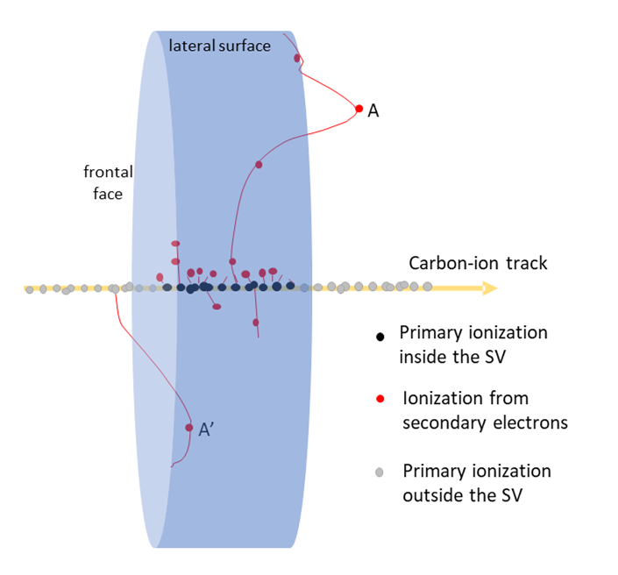

Figure 7. Illustration of an ideal condition of an ion crossing the central axis of the sensitive volume of a microdosimeter. See text for description.

In the more realistic scenario, the particles imping the detector at random positions and some energetic delta rays may escape transversally the SV. Also in this case, each escaping delta ray is statistically compensated by a delta ray entering the SV which may arise however by a different primary ion. Those secondary ionizations are not simultaneous with any primary event recorded and therefore are accounted as independent events, which we can name “solitary delta-ray” events. The resulting probability distribution is less populated of events in the high-energy part, and more populated in the low-energy part due to additional solitary delta-ray events. In this case the expectation value obtained from the microdosimetric distribution does not provide the unrestricted LET but a value which underestimates it.

Realistically speaking, the cross-sectional area cannot be increased indefinitely because of two harmful consequences. First, the particle flux increases, and a limit is reached when it becomes impossible to separate temporarily the different events so that pile-up distortions increase. Second, the increase of the area results in increasing the capacitance of the detector and the consequent decrease of the of the signal-to-noise ratio. These conditions are quite restrictive and, at typical clinical beam fluxes the maximum cross-sectional area can be indicatively 0.01 mm². These limits may be expanded by using faster shaping times and multi-sensor detectors featuring matrixes of microdosimeters.

    - Nanodosimeter
Nanodosimetry provides measurements of the number of ionizations in a site of a few nanometers. Typical experimental setups are included in a large tank filled with tissue-equivalent gas at low pressure. The detecting system inside the tank is composed of the primary-particle tracking system and a drift chamber for the detection of the single ionizations. The pressure is set to scale the sizes from the physical millimeters of the setup down to represent nanometers in simulated tissue [Bantsar 2018]. The tracking system detects when the primary particles cross a specific trajectory and triggers the acquisition. The aperture of the drift chamber defines the sensitive volume and is moved perpendicular to the track, at different distances (impact parameters) from the trajectory axis. Some electrons generated by the primary particle enter the aperture of the chamber, drift along the chamber, separate in time and are then counted individually. In this way it is possible to assess the number of ionizations produced by the primary particle collisions of the nanometric volume of interest as the function of the impact parameter.
The nanodosimetric information is reported via the distribution of ionization cluster size which corresponds to the number of ionizations in the nanometric sensitive volume, collected at different impact parameters. When the impact parameters exceed a few tens of nanometers, the measurement becomes unpractically long. This is because the solid angles covered by the chamber’s aperture decreases with the square value of the distance from the track. Already at primary-ion energies of 0.5 MeV·u⁻¹, the delta rays ranges would exceed 60 nm in water, making virtually impossible for nanometric measurements to provide restricted LET information.
  - Passive detectors
A generic passive detector relies on temporary or permanent chemical modifications or other structural damages in the sensitive material in response to the energy imparted along the path by ionizing particles. The correlation to LET is based on the assumption that these modifications are linked directly or indirectly to ionization density.

As stated above, to understand if a passive method is suitable for measuring unrestricted LET of clinical beams, it is necessary to assess its capability in detecting the sparse ionizations of the most energetic delta rays up to the maximum distances of a few millimeters from the core of the track. Different types of passive materials have been used as sensors and, in those studies, the outcomes are described, at times, as a track- or dose-averaged unrestricted LET. An extensive critical review was recently carried out by Christensen [Christensen 2024]. Many times, the description is vague, not clearly stating what LET parameter is represented, a problem clearly emphasized by Christensen.

In the context of radiation therapy, the suggested passive detectors are based on phenomena related to the local density of the ionizations. These include luminescence phenomena on the irradiated sample which appear offline after external stimulations that are thermic, optical, or done with radiofrequency. Other methods include the microscopic detection of tracks formed either directly or chemically etched, the electron-spin resonance detection of radicals, quantification of chemical reaction products and polymerization in gels and films. The material responses have different levels of uncertainties, range of operation, and threshold sensitivity (minimum dose required) and correlation to specific radiation-quality parameter. Implementing these processes towards the determination of radiation quality goes through the identification of the conversion function which links the particular effect to the density of ionization and, in turn, averages of distributions of restricted LET, unrestricted LET, or lineal energy.
    - Luminescence detector
Extensively used for dosimetry, luminescence detectors provide information on the density of the ionizations. Besides the techniques used to extract the information offline which include thermal and optical stimulations and radiofrequency, the responses of the materials to ionizing are linked to the trapping of the charges generated and their successive release.
For thermoluminescent detectors, TLD, the glow curves, which represent the light output when the material is exposed to increasing temperatures, show characteristic peaks. The ratio of amplitudes of different peaks shows a dependence on the spatial distance between the trapped charges which is correlated to the LET.
The luminescence response is cumulative, obtained offline, and cannot be related to single events. Therefore, it cannot provide LET distributions, however, in mixed radiation fields, the doses imparted on lower LET and higher LET intervals have been estimated comparing the response of two different luminescent materials whose relative efficiencies diverge strongly with LET and can be exploited.
TLDs have been applied to distinguish low-LET dose and high-LET dose in photon-neutron mixed radiation fields [Massillon 2006]. Radiation-quality determination based on TLDs have been applied in proton-beam therapy [Mukherjee 2011].
Extending the approach to heavier ions, studies have combined thermoluminescent materials with different LET sensitivities to distinguish radiation contributions originating from the dense track core from those arising in the δ-ray penumbra [Olko 2002].
Although not truly spectrometric, this approach can be interpreted as a simplified LET-resolved analysis, where the dose distribution is separated into only two LET regions, broadly corresponding to lower- and higher-LET components.
    - Fluorescent nuclear track detector
In fluorescent nuclear track detectors (FNTDs), each ionizing particle produces defects along the track within the medium. Those are visualized with micrometric spatial resolution and represented in spectra according to their fluorescence intensity. FNTDs provide a methodology for assessing the LET relying, in monoenergetic beams, on empirical comparison between the experimentally recorded fluorescence spectra and reference LET values [Muñoz 2023].
For low‑energy particles and sufficiently large sensitive volumes, the entire track can be visualized down to the stopping point; a typical case is for boron‑neutron capture applications, were FNTD may clearly distinguish the alpha and lithium tracks generated [Galuzzi 2025]. For ions of higher energy, however, crossing tracks are registered. The fluorescence response depends on the ion species, and the transverse extent of the corresponding track structure typically extends only a few micrometers from the particle trajectory. Conseuently, the contribution from high‑energy δ‑electrons is therefore not fully accounted for. As a result, the applicability of FNTDs is limited to the assessment of restricted LET, since those detectors cannot capture the complete radial distribution of energy deposited by high‑energy secondary electrons.
    - Track-etched detector
In track-etched detectors (TEDs), the dense ionization produced along a charged-particle trajectory creates a region of chemical and structural damage that remains invisible until chemical etching is performed. The etching process is generally assumed to be isotropic, such that the dimensions of the etched track are related to the characteristics of the original damage zone. Consequently, the diameter and morphology of the etched track depend on the particle type and its LET. Optical analysis of the etched tracks therefore provides an indirect estimate of LET [Spurný 2001]. Each etched track is recorded individually as function of its diameter which serves as a measure of the local ionization density. As a result, TEDs can provide a simplified spectrometric representation of the radiation field, allowing the reconstruction of both frequency- and dose-related distributions as a function of LET.
The etched tracks produced by heavy ions typically exhibit diameters of several tens of micrometers. However, the radial extension of high-energy δ rays may be considerably larger, extending far beyond the dimensions of the observable track. Consequently, track-etched detectors are not suitable for the direct determination of unrestricted LET for high-energy ions, as they do not capture the full spatial distribution of energy deposited by distant secondary electrons.
    - Electron-spin resonance detector
The electron-spin resonance (ESR) detectors exploit the formation of radiation-induced radicals in certain materials. These detectors show an indirect sensitivity to radiation quality because yield and stability of the radiation-induced radicals depend on the local pattern of energy deposition. The information on the distance between the free radicals is captured in the material.
Non-destructive measurement at increasing radiofrequencies provides information on the spatial distribution of the ionizations which are correlated to the LET [Marrale 2014]. Each measurement requires doses of several tens of grays and therefore correspond to the cumulative contribution of billions of collisions. The methodology suggested appears ineffective in accounting for the rare delta rays with highest energy, and the correlation of the experimental results is with the restricted LET.
The technique was preliminary tested at dose level of the order of 100 Gy, providing a spatial resolution comparable with the size of the irradiated pellets.
    - Gel
Ionizing radiation induces chemical modifications in radiation‑sensitive gels, and these changes can be spatially resolved after irradiation. In polymer gels, the radiation‑driven polymerization of monomers shows a measurable dependence on the local ionization density, as demonstrated by Gustavsson et al. [Gustavsson 2004]. This sensitivity to track structure suggests that gels could, in principle, be exploited for assessing radiation quality.
Comparable indications arise from radiochromic films, which have been used to infer the spatial distribution of LET [Mayer 2015]. In these films, ionizing radiation initiates the polymerization of monomers within the active layer, producing a localized darkening. The response exhibits LET quenching: the apparent sensitivity decreases for densely ionizing radiation because the finite number of available monomers cannot sustain a linear correlation between darkening and ionization density. This saturation effect leads to a systematic deviation between the nominal dose of a radiation field and the dose measured by the film, and this discrepancy can be correlated with LET.
The film response is averaged over the region corresponding to each scanned pixel. The pixel size, typically of the order of a few tenth of a millimeter, represents the spatial scale over which the optical signal is averaged. In contrast, the physical effects produced by an individual charged-particle track within the gel are localized to regions only a few micrometers in size.
To exploit gels or radiochromic films for LET assessment, a dedicated calibration procedure must be established, enabling an empirical correlation between the measured signal and the underlying ionization density.

Table 1. LET distributions in active and passive detectors in ionization beams
 | Representation | Correlated delta-ray energy | Limits of operability | Correlation to LET distribution
TEPC Microdosimeter | distribution: lineal-energy spectra; correlated values frequency and dose mean lineal energy | <4 keV | single ionization ~10 eV | f(L_{res}) (probability-density distribution of restricted LET)
Solid-state Microdosimeter | distribution: lineal-energy spectra; correlated values: frequency and dose mean lineal energy | variable with SV sizes  ~4-50 keV | minimum imparted energy ~ 1 keV | f(L_{res})
Nanodosimeter | distribution: ionization cluster-size distribution; correlated values:  cluster-size moments | <100 eV | single ionization ~10 eV | f(L_{res})
FNTD  fluorescent nuclear track | distribution: particle tracks characteristics | undefined | single track | f(L_{res})
TED  track-etched | distribution: particle tracks characteristics | undefined | single track | f(L_{res})
TLD, OSL,  luminescence | value: glue curve peak ratio | undefined | 0.1 Gy | LET, averaged over response functions r(L_{res})  (*)
ESR  Electron-spin resonance | value: resonance peak amplitude | undefined | - high dose (>50 Gy)  - resolution ~2 mm | LET, averaged over response functions r(L_{res})  (*)
Films/Gel | value: darkening, saturation | undefined | - Resolution ~0.2 mm | LET, averaged over response functions r(L_{res})  (**)
Table 1 summarizes the results of the prior discussion.
(*) The response function r(L_{res}), is possibly different from both frequency f(L_{res}) and dose probability density function d(L_{res})
(**) Resh et al. [Resh 2020] show higher resemblance of the average taken with Radiochromic® films with L̄_{D} for protons in a limited range of energies.

  - Other systems
    - Quenching effect
Quenching effects, including the initial recombination of charge carriers, arise from the high local density of ionizations produced by densely ionizing radiation. When the concentration of charges or radicals becomes sufficiently large, their probability of recombination increases, reducing the efficiency of signal formation in the detector.
In both active and passive detectors, this reduction manifests as a deviation from linearity at high radiation densities, and this behavior can be correlated with LET. In passive systems, such as the Radiochromic© films discussed above, the quenching effect accumulates over a large number of events and is observed as a systematic under‑response in regions exposed to high‑LET radiation. In active detectors, quenching, caused by initial ion recombination, alters the signal amplitude of individual events.
Different detection systems implement distinct mechanisms to recover or interpret this information, enabling their use for radiation‑quality assessment. Depending on the detector, this may involve analyzing the amplitude of individual pulses, studying changes in efficiency or light yield, and calibrating the integral signal loss as a function of LET. Despite their detector‑specific characteristics, all such approaches rely on the fundamental link between quenching and ionization‑density effects.
    - Systems with highest metrology
A detection system capable of measuring the energy of individual particles before and after traversing a sampling material would represent, in principle, the most accurate and complete approach to LET determination. Such an arrangement could provide the unrestricted LET directly from the energy difference, enabling the reconstruction of detailed LET spectra without relying on indirect indicators of ionization density.
Implementing this concept requires highly specialized instrumentation, typically involving extended setups that combine multiple tracking planes, dedicated energy‑measurement stages, and time‑of‑flight systems. Such configurations demand substantial physical dimensions, strict mechanical alignment, and advanced electronic readout, placing them well beyond the capabilities of routine dosimetry systems. Consequently, these approaches are generally feasible only in advanced metrological facilities or in environments where space, cost, and operational complexity can be justified. When available, they provide high‑quality measurements suitable for the benchmark validation of microdosimetric methods and Monte Carlo models.

- References

[Bantsar 2018] Bantsar A, Colautti P, Conte V, Hilgers G, Pietrzak M, Pszona S, Rabus H, Selva A. State of the art of instrumentation in experimental nanodosimetry. Radiation Protection Dosimetry. 2018 Aug 1;180(1-4):177-81.

[Bethe 1930] H. Bethe, Zur Theorie des Durchgangs schneller Korpuskularstrahlen durch Materie, Annalen der Physik, 397, 325–400 (1930) doi:10.1002/andp.19303970303

[Brenner 1998] Brenner DJ, Zaider M., Letters to the editor: Estimating RBEs at clinical doses from microdosimetric spectra. Medical Physics. 1998; 25(6):1055-7.

[Berger 1982] Berger MJ, Seltzer SM. Stopping powers and ranges of electrons and positrons. NBSIR 82-2550. Washington, DC: National Bureau of Standards (now NIST), 1982.

[Bobić 2024] Bobić M, Christensen JB, Lee H, Choulilitsa E, Czerska K, Togno M, Safai S, Yukihara EG, Winey BA, Lomax AJ, Paganetti H. Optically stimulated luminescence dosimeters for simultaneous measurement of point dose and dose-weighted LET in an adaptive proton therapy workflow. Frontiers in Oncology. 2024 Jan 8;13:1333039.

[Christensen 2024] Christensen JB, Muñoz ID, Bilski P, Conte V, Olko P, Bossin L, Vestergaard A, Agosteo S, Rosenfeld A, Tran L, Knežević Ž. Status of LET assessment with active and passive detectors in ion beams. Radiation measurements. 2024 Sep 1;177:107252. https://doi.org/10.1016/j.radmeas.2024.107252

[Conte 2012] Conte V, Colautti P, Grosswendt B, Moro D, De Nardo L. Track structure of light ions: experiments and simulations. New Journal of Physics. 2012 Sep 7;14(9):093010.

[Galuzzi 2025] Galuzzi L, Parisi G, Pascali V, Niklas M, Bortot D, Protti N, Altieri S. Fluorescent Neutron Track Detectors for Boron-10 Microdistribution Measurement in BNCT: A Feasibility Study. Materials. 2025 Jan 29;18(3):621

[Gustavsson 2004] Gustavsson H, Sven ÅJ, Medin J, Grusell E, Olsson LE. Linear energy transfer dependence of a normoxic polymer gel dosimeter investigated using proton beam absorbed dose measurements. Physics in Medicine & Biology. 2004 Sep 7;49(17):3847-55.

[Hagiwara 2019] Hagiwara Y, Bhattacharyya T, Matsufuji N, et al. Influence of dose-averaged linear energy transfer on tumour control after carbon-ion radiation therapy for pancreatic cancer. Clin Transl Radiat Oncol 2019;21:19–24. https://doi.org/10.1016/j.ctro.2019.11.002.

[Hajek 2004] Hajek M, Berger T, Vana N. A TLD-based personal dosemeter system for aircrew monitoring. Radiation Protection Dosimetry. 2004 Aug 1;110(1-4):337-41.

[Hawkins 1994] Hawkins R. A statistical theory of cell killing by radiation of varying linear energy transfer. Radiat Res 1994;140:366–74. https://doi.org/10.2307/3579114.

[Inaniwa 2010] Inaniwa T, Furukawa T, Kase Y, Matsufuji N, Toshito T, Matsumoto Y, et al., Treatment planning for a scanned carbon beam with a modified microdosimetric kinetic model. Phys Med Biol 2010;55:6721–37. https://doi.org/10.1088/0031-9155/55/22/008

[Inaniwa 2017] Inaniwa T, Kanematsu N, Noda K, et al. Treatment planning of intensity modulated composite particle therapy with dose and linear energy transfer optimization. Phys Med Biol 2017;62:5180–97.

[Kalholm 2021] Kalholm F, Grzanka L, Traneus E, Bassler N. A systematic review on the usage of averaged LET in radiation biology for particle therapy. Radiotherapy and Oncology. 2021 Aug 1;161:211-21.

[Kellerer 1972] Kellerer AM. An algorithm for LET-analysis. Physics in Medicine & Biology. 1972 Mar 1;17(2):232.

[Kellerer 1985] Kellerer AM, Fundamentals of microdosimetry, Chapter in ‘The dosimetry of ionizing radiation: Volume I’, Kase KR, Bjärngard BE, Attix FH Editors, Academic Press, Inc. Harcourt Brace Jovanovich, Publishers, 1985
[Koto 2024] Koto M, Ikawa H, Inaniwa T, et al. Dose-averaged LET optimized carbon-ion radiotherapy for head and neck cancers. Radiother Oncol 2024;194:110180.
[ICRU-16 1970] International Commission on Radiation Units and Measurements. Linear Energy Transfer. ICRU Report 16. Bethesda, MD, 1970.
[ICRU-37 1984] International Commission on Radiation Units and Measurements. Stopping powers for electrons and positrons: [26 elements, 49 compounds and mixtures]. ICRU Report 37. Bethesda, MD: ICRU; 1984.
[ICRU-49 1993] International Commission on Radiation Units and Measurements. Stopping powers and ranges for protons and alpha particles. ICRU Report 49. Bethesda, MD: ICRU; 1993
[Loncol 1994] Loncol T, Cosgrove V, Denis JM, Gueulette J, Mazal A, Menzel HG, Pihet P, Sabattier R. Radiobiological effectiveness of radiation beams with broad LET spectra: microdosimetric analysis using biological weighting functions. Radiation Protection Dosimetry. 1994 Apr 1;52(1-4):347-52., https://doi.org/10.1093/oxfordjournals.rpd.a082212
[Magrin 2018] Magrin G. A method to convert spectra from slab microdosimeters in therapeutic ion-beams to the spectra referring to microdosimeters of different shapes and material. Physics in Medicine & Biology. 2018 Oct 29;63(21):215021.
[Mayer 2015] Mayer R, Lin L, Fager M, Douglas D, McDonough J, Carabe A. Proposed linear energy transfer areal detector for protons using radiochromic film. Review of Scientific Instruments. 2015 Apr 1;86(4). https://doi.org/10.1063/1.4917418
[Mukherjee 2011] B. Mukherjee, J. Lambert, R. Hentschel and J. Farr, Radiat. Meas. 46, 1952 (2011)
[Marrale 2014] Marrale M, Longo A, Brai M, Barbon A, Brustolon M. Discrimination of radiation quality through second harmonic out-of-phase cw-ESR detection. Radiation research. 2014 Feb 1;181(2):184-92.
[Massillon 2006] Massillon-Jl G, Gamboa-deBuen I, Brandan ME. LET and dose dependence of TLD-100 glow curve after exposure to intermediate-energy ions. Radiation protection dosimetry. 2006 Sep 1;120(1-4):341-4.

[Matsumoto 2020] Matsumoto S, Lee SH, Imai R, et al. Unresectable chondrosarcomas treated with carbon ion radiotherapy: relationship between dose-averaged linear energy transfer and local recurrence. Anticancer Res 2020;40:6429–35. https://doi.org/10.21873/anticanres.14664.

[Molinelli 2021] Molinelli S, Magro G, Mairani A, et al. How LEM-based RBE and dose-averaged LET affected clinical outcomes of sacral chordoma patients treated with carbon ion radiotherapy. Radiother Oncol 2021;163:209–14. https://doi.org/10.1016/j.radonc.2021.08.024.

[Muñoz 2023] Muñoz ID, Burigo LN, Gehrke T, Brons S, Greilich S, Jäkel O. Sensitivity correction of fluorescent nuclear track detectors using alpha particles: Determining LET spectra of light ions with enhanced accuracy. Medical physics. 2023 Apr;50(4):2385-401.

[Olko 2002] Olko P, Bilski P, Budzanowski M, Waligórski MP, Reitz G. Modeling the response of thermoluminescence detectors exposed to low-and high-LET radiation fields. Journal of radiation research. 2002;43(S):S59-62.

[Palmans 2015] Palmans H, Rabus H, Belchior AL, Bug MU, Galer S, Giesen U, Gonon G, Gruel G, Hilgers G, Moro D, Nettelbeck H. Future development of biologically relevant dosimetry. The British journal of radiology. 2015 Jan 1;88(1045):20140392.

[Parisi 2019] Parisi A, Chiriotti S, De Saint-Hubert M, Van Hoey O, Vandevoorde C, Beukes P, De Kock EA, Symons J, Camero JN, Slabbert J, Mégret P. A novel methodology to assess linear energy transfer and relative biological effectiveness in proton therapy using pairs of differently doped thermoluminescent detectors . Physics in Medicine & Biology. 2019 Apr 5;64(8):085005.]
[Parisi 2020] Parisi A, Sato T, Matsuya Y, Kase Y, Magrin G, Verona C, Tran L, Rosenfeld A, Bianchi A, Olko P, Struelens L. Development of a new microdosimetric biological weighting function for the RBE10 assessment in case of the V79 cell line exposed to ions from 1H to 238U. Physics in Medicine & Biology. 2020 Dec 2;65(23):235010.

[Pihet 1999] Pihet P, Menzel HG, Letters to the editor: Response to the Letter to the Editor “Estimating RBEs at clinical doses from microdosimetric spectra”, Medical Physics. 1999; 26(5):848-52

[Rossi 1968] Rossi HH. Microscopic energy distribution in irradiated matter. Radiation dosimetry. 1968 Jan 1;1:43-92.

[Spurný 2001] Spurný F, Bottollier-Depois JF, Vlček B. Spectrometry of the LET with track etched detectors—correlation with proportional counter measured spectra. Radiation measurements. 2001 Jun 1;34(1-6):193-7.

[Wilson 2018] Wilson G, Starley A, Phillipps L, Dennison JR. Electron Range Computational Tool for Arbitrary Materials over a Wide Energy Range [Excel tool]. Version 1.1. Materials Physics Group, Utah State University; 2018. Presented at: 15th Spacecraft Charging Technology Conference; 2018 Jun 25–29; Kobe, Japan; IEEE; 2018. p. 1–8. doi:10.1109/SCTC.2018.00017

Internal reference on files used for figures and calculations

Figure 1: Energy_straggling_convolutions-FFT-29Jan2025-general-Impact_parameter
Figures 3 and 4: Numbe_of_ionizations_of_primaries_and_delta_24Apr2025;
Numbe_of_ionizations_of_primaries_and_delta_11Feb2025 (projectile: carbon-ion; atomic number=6; mass number=12 target: silicon; atomic number=14; mass number=28; w-value=3.62eV; density=2.32 g·cmˉ³; band gap=1.12eV)
Numbe_of_ionizations_of_primaries_and_delta_8Mayr2024
Figure 5: Collision_distribution_with_arrays_10Dec2025
Figure 6: Collision_distribution_with_arrays_10Dec2025
Old Figure 6: Energy_straggling_convolutions-FFT-14Feb2025-Rossi_graph.ipynb

Figure 7: R:\Medical\Personal\GMN\My-Articles-Posters-Talks\-2025-Chapters of Microdosimetry for the Web\Figures\Figure 7 Blue.pptx
Section 2.1: electron density+primary and secondary ionizatios.xlsx
File for the calculation of the electron CSDA ranges of electrons in different materials [Wilson 2018]:
R:\Medical\Personal\GMN\Papers-Presentations-documents\+TOPICS\Stopping Power tables\Range Calculator.cleaned.xlsm
Reference to be read for section 4: https://iopscience.iop.org/article/10.1088/1361-6560/ae128f

Chapter BLUE
Version | Date | Authors | Major changes and comments
0.0 | 28 July 2025 | Giulio Magrin | Added material
0.1 | 12 Aug 2025 | Giulio Magrin, Hugo Palmans | First revision and integration of Hugo Palmans feedbacks
0.2 | 18 Dec 2025 | Giulio Magrin | Implementing the “conceptual variants” of LET distributions,
0.3 | 26 Feb 2026 | Giulio Magrin, Hugo Palmans | Implemented Monte Carlo section, general revision of passive detectors
0.4 | 13 Aug 2026 | Giulio Magrin, Hugo Palmans | First uploaded version excluding Monte Carlo
Intellectual Property (IP) Statement:
"This document is the result of collaborative research conducted by the undersigned authors. All intellectual property rights associated with the content herein remain with MedAustron and the Institutions of other contributing authors, and any use, reproduction, or distribution must be authorized by the Institutions involved”

In this discussion, the term ionization is used in a broad sense, even though charge generation in semiconductor detectors does not strictly involve ionizations but rather the release of charge carriers through collision processes. A more accurate expression in that context would be charges freed in collisions. However, the primary focus of this work is the interaction of charged particles in biological tissue, where true ionizations are indeed produced. For the sake of readability and to avoid cumbersome phrasing when this concept is referenced repeatedly, the term ionizations is retained throughout the text.
Section 6 will be included after further revisions.
Section 7 will be inserted after the submission of the paper on this topic

