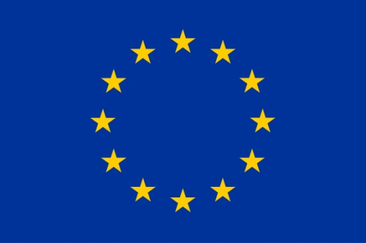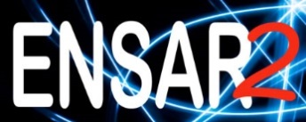
MediNet
Midterm Meeting of NA5 Networking Activity 5: Medical Network
ENSAR2 - European Nuclear Science and Application Research 2

March 12th - 14th, 2018
Vinča Institute of Nuclear Sciences, University of Belgrade, Belgrade, Serbia

REGISTRATION FORM
First Name
Family Name
Position
Institution
Address
City
Country
Phone
e-mail
Passport number
(needed to enter Vinča Institute of Nuclear Sciences)
Have you any special requirements regarding food?
(vegetarian, intolerances…)
If you intend to present a Poster, please provide a tentative title and the research topic

Please complete the form electronically and send it by email to giulio.magrin@medaustron.at by Monday 12 February, 2018

