**Stochastic nature of radiation interactions in ion beam therapy**

(Authorships and date are indicated in the table at the end of the document)

**Preamble**

Before delving into the specifics, it is important to clarify certain concepts that relate to stochasticity and ionizing radiation and are often misunderstood or conflated with the stochastic nature of radiation interactions:

*Stochastic interactions vs. stochastic effects.* It is crucial to distinguish between the stochastic nature of radiation interactions, which refer to the probabilistic behavior of particles at the microscopic level, and stochastic effects, which indicate biological responses to radiation exposure relevant in the context of radioprotection. Although these terms are occasionally associated, they describe fundamentally different phenomena.

*Distributions and stochasticity*. The representation of a quantity as a distribution does not inherently imply that the quantity itself is stochastic. A pertinent example is the distribution of linear energy transfer (LET), which, despite being expressed as a distribution, is not expressing stochasticity.

1. **Context and background**

The interaction of ionizing radiation with biological tissues, especially in the context of clinical ion beams for cancer therapy, is governed by complex, multiscale energy deposition processes. At the heart of this complexity lies a central paradox: while energy imparted by radiation is stochastic at nano-metric and micro-metric scales, the resultant clinical effects display reproducible patterns that contradict this randomness. Defining and quantifying this relationship is critical for advancing both mechanistic radiobiological understanding and the optimization of particle therapy protocols.

The objective of this chapter is to demonstrate that, within the context of ion-beam therapy, the insights provided by microdosimetric spectra are predominantly of a non-stochastic nature, with only limited relevance to the stochastic characteristics of radiation interactions. This argument is developed through a structured exploration of key concepts.

The discussion begins by defining the stochastic nature of radiation interactions. It then examines how microdosimetry—particularly in scenarios involving nearly monoenergetic ion beams—exhibits strong correlations with deterministic parameters such as LET. In more complex and heterogeneous irradiation fields, microdosimetric measurements continue to align closely with LET distributions. These observations suggest a prevailing relationship with deterministic quantities rather than with inherently stochastic processes.

A central thesis of this chapter is that the commonly perceived association between microdosimetry and the stochastic nature of radiation interactions largely originates from its historical application to indirectly ionizing particles. This legacy has significantly influenced the conceptual framework of the field.

1. **Randomness of interactions**

When ion beams are tailored to conform radiation to a tumor target under specific clinical constraints, random effects must be considered, as they contribute to the overall stochasticity of the process. Let us consider ionizing radiation composed of particles of a defined type and energy. The stochastic nature of radiation interactions with matter has a precise meaning, which can be broken down into the following components:

a) Random Collisions with Matter

A charged particle traversing a target interacts randomly with individual electrons and nuclei of the medium. These interactions are governed by electronic collisions, described by probability distributions of electron interactions and nuclear interactions, characterized by nuclear cross sections.

b) Stochastic Energy Transfer

The energy transferred in each collision is itself a stochastic variable. For clinical ions interacting with electrons in the medium, the energy transfer spans over five orders of magnitude—from a few electron-volts (eV) to some mega-electron-volts (MeV). Notably, lower-energy interactions are far more probable than high-energy ones.

As a particle travels a distance *d* through a medium, the total energy lost via electronic collisions results from a series of random events. Each collision occurs with a certain probability (as described in point a) and transfers a variable amount of energy (as described in point b). The cumulative effect of these interactions is known as energy-loss straggling, which depends on the path length *d*.

Energy-loss straggling will also result in energy straggling, i.e., at a certain depth in a phantom or a patient, the energy spectrum will have widened as compared to the phantom surface. While this is resulting from the stochasticity of radiation interaction, it is not related to the stochasticity of imparted energy at that point in the phantom.

c) Particle Number Fluctuations

The number of particles traversing a sensitive volume is a random variable, governed by a probability distribution dependent on fluence and, consequently, on dose. While this stochasticity does not affect microdosimetric representations in terms of lineal energy, it is relevant for spectra of other quantities, such as multi-event distributions of specific energy, and energy imparted. Such distributions are less commonly used today, but the debate over their relevance—especially in high-intensity radiation fields where multiple particles strike a single cell nucleus—remains unresolved (e.g. the debate [Brenner 1998] vs. [Pihet 1999]).

Experimental spectra based on lineal energy, single-event energy imparted (ε₁), and single-event specific energy (z₁) are the consequence of the stochastic processes (a) and (b). Experimental spectra based on multi-event energy imparted (ε), and multi-event specific energy (z) are the consequence of the stochastic processes (a), (b), and (c).

**Additional factors influencing spectral representations**

There are other stochastic aspects related to radiation quality that do not stem directly from the stochastic nature of energy interactions. These are discussed here to prevent misinterpretation. Uncertainties related to detector readout electronics and signal conversion are excluded from this discussion.

d) Geometry of the sensitive volume

The shape and size of the sensitive volume influence how energy interactions are represented. In non-flat geometries (e.g., spherical volumes), the chord length, which represents the path a particle travels through the volume, varies depending on the point of entry. This affects the spectral profile, especially at low statistics.

As the number of particles increases, the distribution of impact points becomes more uniform and the stochasticity disappears; the chord length distribution converges toward a predictable geometric form—such as a triangular distribution in spherical geometries. Under these conditions, geometric effects can be effectively corrected using post-processing techniques, as demonstrated by Kellerer [Kellerer 1972].

In contrast, flat sensitive volumes with nearly parallel ion trajectories (as in solid-state detectors used in therapy) yield spectra that are largely independent of geometry, minimizing related uncertainties [Magrin 2018].

e) Escape of delta rays

The cross-sectional area of the sensitive volume also plays a critical role. High-energy secondary electrons (delta rays) may escape the volume laterally, carrying away part of the deposited energy. Whether a delta ray escapes, it depends on its energy (and thus its range), which is governed by the stochasticity of collisions (point b). The concept of delta-ray escape is useful to explain the difference between energy loss and energy imparted [Kellerer; Magrin et al., 2022].

f) Energy spread in accelerated ion beams

In addition to the previously discussed stochastic factors, energy spread in accelerated ion beams represents another source of stochasticity. Although clinical ion beams are often described as monoenergetic, in practice, the energy of individual particles varies within a narrow range. Prior to entering the target, this energy uncertainty is minimal—typically around 0.5% for synchrotrons and 0.1% for cyclotrons.

However, passive beam-modifying elements such as ripple filters are frequently employed to intentionally broaden the energy spectrum. This ensures a more uniform dose distribution across treatment voxels and contributes to the formation of a smooth Spread-Out Bragg Peak (SOBP). The resulting energy spread can span a few MeV from the nominal energy, and its impact becomes particularly significant at lower energy levels, where even small variations can influence the dose deposition profile and ultimately biological effectiveness.

As mentioned already, resulting from energy-loss straggling the energy spread will also widen with increasing depth representing another similar stochastic influence factor which is not related to the stochasticity of energy imparted at the point of interest.

g) Non-stochastic heterogeneity from treatment planning

In ion-beam therapy, it is also essential to discuss the non-stochastic heterogeneity, which arises from the optimization process of treatment planning. Tumor irradiation is guided by a treatment planning system (TPS) designed to conform both dose and radiation quality to clinical prescriptions, to maximize therapeutic effectiveness while minimizing harm to surrounding healthy tissue. This is achieved by dynamically adjusting beam parameters of transverse position, energy, and intensity. Each voxel (sub-volume) of the target may receive contributions from dozens of beams with varying energies and directions. As a result, the radiation quality within a single voxel is an aggregate of multiple beam components. Consequently, the radiation quality distribution in each voxel is unique and differs from neighboring voxels. Although this heterogeneity can be represented by a distribution, it is not stochastic in nature and it is instead a deterministic outcome of the treatment optimization process.

In some TPS, the role of representing in each voxel this radiation heterogeneity is currently fulfilled by the LET probability distributions in dose (or fluence).

1. **Stochasticity and non-charged ionizing radiation**

*Historical Context: Microdosimetry in photon and neutron fields.*

At its inception in the 1950s and for several decades thereafter, microdosimetry was primarily concerned with radiation fields composed of photons and neutrons. In these contexts, ionizations arise from indirect interactions. When gamma rays or X-rays traverse biological tissue, their behavior—whether scattering, absorption, or transmission without interaction—is governed by probabilistic processes dependent on the material’s properties. Similarly, neutron interactions such as elastic scattering, inelastic scattering, or capture are dictated by nuclear cross-sections, which are inherently stochastic.

When these neutral particles interact with matter, they may produce secondary charged particles, such as photoelectrons or recoil ions, which, if they enter the sensitive volume of a detector, are registered as events. These processes correspond to the stochastic mechanisms described in points (a) and (b) of the previous section.

The resulting microdosimetric spectra reflect two layers of stochasticity, the probabilistic generation of secondary charged particles from primary neutral radiation and the stochastic interactions of these secondary particles within the detector medium. Due to the diversity of particle types and energies involved, the radiation quality in such fields is highly heterogeneous and the microdosimetric spectra span several orders of magnitude of lineal energy.

*Illustrative example: Mixed photon-neutron field.*

Figure 1 presents a conceptual illustration of a microdosimetric spectrum measured using a spherical tissue-equivalent proportional counter (TEPC) simulating a tissue volume of 1 µm, exposed to a mixed photon-neutron field with neutron energies of a few MeV. This figure is intended for explanatory purposes and does not represent empirical data. The spectrum extends from approximately 10 eV/µm to 1000 keV/µm.

Gamma radiation contributes to the lower end of the spectrum, typically from a few eV/µm up to 10 keV/µm.

Neutrons, through interactions with atomic nuclei in the medium, produce a variety of secondary ions differing in type, energy, and direction. These ions populate distinct regions of the spectrum. Recoil protons dominate the mid-range, typically tens of keV/µm up to approximately 100 keV/µm. Heavier ions (e.g., carbon, oxygen) contribute to the higher end, extending up to 1000 keV/µm.

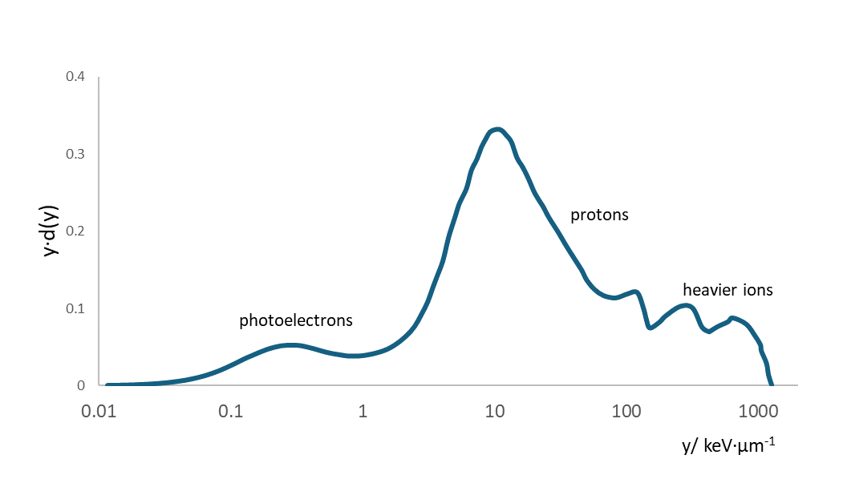

***Figure 1***: Illustrative representation of a lineal-energy spectrum for a mixed photon-neutron field (neutron energy of a few MeV), measured with a spherical microdosimeter simulating 1 µm of tissue. For actual experimental data, refer, for instance, to ICRU Report 98, Figure 6.1 (not reproduced here due to copyright restrictions).

1. **Stochasticity and Charged Ionizing Radiation**

As discussed in the previous section, for indirectly ionizing radiation (e.g., photons and neutrons), the energy imparted to a micrometric site result entirely from random processes in the sense that also the sources of charged particles are random processes such as de-excitation and spallation. Consequently, microdosimetric spectra in such fields fully reflect the stochastic nature of energy deposition. This historical context has contributed to a strong lexical and conceptual association between microdosimetry and stochasticity, an association that persists even in the context of directly ionizing particles, such as those used in ion-beam therapy. A critical reassessment is necessary. In ion-beam therapy, stochastic and non-stochastic elements coexist, and their contributions must be carefully disentangled [see Kellerer 1972].

**Mixed contributions in microdosimetric spectra**

To illustrate this dual nature, let us consider the experimental microdosimetric characterization of a monoenergetic carbon-ion beam, as performed at MedAustron. Figure 2 presents a lineal-energy frequency spectrum collected using a silicon microdosimeter in a 118 MeV/u carbon-ion beam. Several key features of the spectrum highlight both stochastic and non-stochastic components:

A: Unrestricted LET

The value of the unrestricted LET indicated by the letter A, is a non-stochastic quantity.

B: Peak lineal energy

The statistical descriptors of the distribution, such as the frequency mean lineal energy (indicated by the letter B), are also non-stochastic. In non-monoenergetic radiation, these values are commonly used in comparisons between microdosimetric means (ȳD and ȳF) and LET-based metrics (LETd and LETt), as documented across various beamlines and institutions, but, as is clear from the example in Figure 2, this is not correct.

C: FWHM of the Gaussian profile

The full width at half maximum (FWHM) of the Gaussian curve (interval C) **reflects the stochastic nature of energy deposition events**. It captures the variability in energy transfer due to the probabilistic nature of particle interactions and it depends on the site size.

D: Low-energy tail from delta rays

The rising edge at lowest lineal energies (interval D) is attributed to delta rays. These events are stochastic in origin and arise from interactions occurring outside the detector.

E: Border effects

The flat region in the intermediate energy range (interval E) results from border effects of the sensitive volume, where primary particles only partially interfere. These distortions are site-shape dependent in nature and, while they can be corrected through post-processing, they are not related to stochasticity. The spectrum represented in figure 2 can be considered as the convolution of the spectrum obtained with a border-distortion-free detector and the chord length distribution in a volume which takes into consideration the effects on the border (this topic is discussed in details in another chapter).

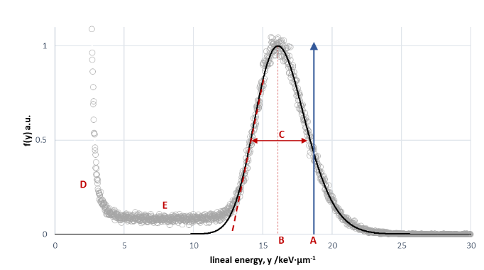 ***Figure 2***: Lineal-energy frequency spectrum f(y) collected with a silicon microdosimeter in a 118 MeV/u carbon-ion beam (open circles). The spectrum is normalized to a unit peak maximum. A Gaussian curve interpolates the peak region. A: Unrestricted LET (blue arrow); B: Peak lineal energy; C: FWHM of the Gaussian; D: Delta-ray contributions; E: Border-effect distortions.

Reversing the process, the spectrum free from border distortions can be obtained by deconvolution, of the experimental spectrum (as the one represented in figure 2) and the chord length distribution of the sensitive volume which includes border effects.

1. **Clinical irradiation**

While monoenergetic beams offer a controlled environment for analysis, clinical ion-beam therapy involves more complex scenarios. Figure 3 refers to the irradiation of a simplified target with an SOBP. In the voxels of the target the radiation is given by the combination of particles stopping in that voxel plus crossing particles stopping in deeper voxels. Since also the transversal distribution of intensity is not uniform at the same depth, the characteristic of the radiation varies from voxels to voxel.

Figure 4 refers to a voxel chosen from plan described in figure 3, at 10 millimeters from the distal depth and at the center of the transversal area. The intensities of the different beams impinging in the voxel are represented as function of the electronic stopping power values. The representation is based on the ideal condition of absence of energy straggling so that, the beam remains monoenergetic also after penetrating the target. Under that condition, the LET distribution is represented simply by the series of discrete LET values (red lines in the figure 4) each corresponding to the monoenergetic beams.

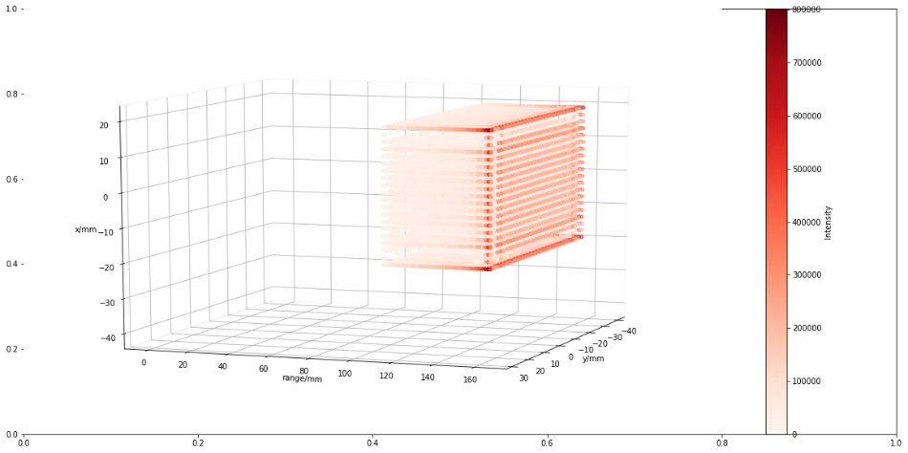

***Figure 3***. Representation of a simple plan in water for the irradiation of voxels in a parallelepiped target. The beams enter horizontally from left to right and their weights are calculated such that their cumulative dose contribution forms an SOBP. The color transparency decreases with the increase of the number of primary particles stopping in that voxel.

In a realistic scenario, the energy straggling and the presence of ripple filters in the beamline would spread the energy so that, instead of discrete LET values, a more uniform distribution would appear, but note that these influences, while stochastic in nature, are not related to the stochasticity of imparted energy at the point of interest.

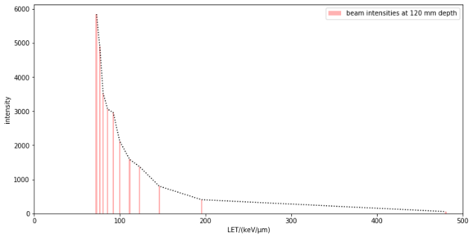

***Figure 4***. Representation of the beam intensities as function of the ideal discrete unrestricted LET values in a voxel at the center of the cross-sectional area at depth in water of 120 mm, 10 mm before the distal edge of the irradiated volume. The dashes black line is used as a guide for the eye between values. The irradiation plan from which the data are extracted is represented in figure 3.

Figure 5 shows the comparison of the experimental spectrum (black line) collected in the position corresponding to the selected voxel of the plan represented in figure 3 with the computed probability-density frequency distribution in lineal energy (continuous red line). The latter is the sum of the quasi-Gaussian curves (dashed lines in multiple colors) which are calculated using the method of multiple convolution [Kellerer 1968, Magrin 2022] for each beam entering the specific voxel, considered as monoenergetic.

The fact that the quasi-Gaussian curves in figure 5 substitute the single values represented in figure 4 is the direct representation of the co-existence of stochastic and non-stochastic nature of the radiation interaction as discussed above and represented in figure 3. It is worth noting the difference of the values of LET in Figure 4 compared to the mean values of lineal energy derived from the quasi-Gaussian distributions shown in Figure 5. This discrepancy arises because the former are based on the energy lost, which is systematically higher than the imparted energy on which the latter are based.

This computation ignores the influence of the ripple filters, which in clinics are used to slightly modulate the monoenergetic energy resulting in a millimetric spread out Bragg peak. The effect of the ripple filters on the spectra would be to spread the lineal energy to higher values and, consequently, make the curve representing the sum of all Gaussian contributions more uniform, in particular at the highest lineal energies. The effect of ripple filters is predetermined and non-stochastic.

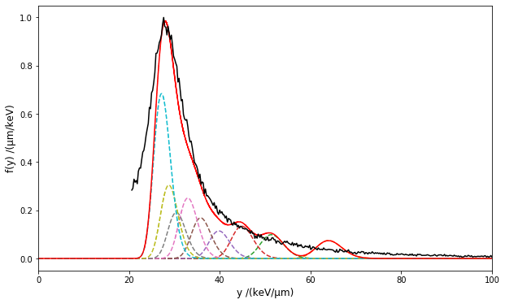

***Figure 5***. Experimental microdosimetric spectrum (black line) representing the frequency distribution in lineal energy, f(y); the spectrum is truncated to exclude the part below 20 keV·µm-1. The quasi-Gaussian curves (dashed lines in multiple colors) are the lineal energy distributions calculated for each distinctive monoenergetic beam entering the voxel represented in figure 3. The envelope of the contributions of all quasi-Gaussian curves is represented with the continuous red line. The normalizations are done to have unitary maxima of the experimental and envelope curves.

In conclusion, the microdosimetric spectra collected in conditions which are realistically representing the clinical irradiation are the result of both stochastic and non-stochastic contributions. The variance of the microdosimetric spectrum can thus be seen as being the combination of variances from stochastic and non-stochastic influences. The comparison of figures 4 and 5, the first being a complete non-stochastic characterization the second being a combination of stochastic and non-stochastic characteristics, is a guide to the discussion on what is the most clinically relevant.

**Stochasticity in today’s uses**

The attention is directed here toward concepts that incorporate spectral information on radiation quality.

*Microdosimetric Kinetic Model (MKM)*. Possibly the most relevant in clinics is the MKM, in which the biological effectiveness is derived using the saturation-corrected dose-mean lineal energy, *y\**.

$$y^{*}=\int_{0}^{∞}{ y f\left(y\right)·w(y,y_{0})ⅆy}$$

where the saturation weighting function *w(y,y0)*, which depends on an experimentally determined parameter *y0* = 150 keV µm−1, is reported hereafter for completeness:

$$w\left(y,y_{0}\right)=\frac{y_{0}^{2}·\left[1-e^{-{\left(\frac{y}{y_{0}}\right)}^{2}}\right]y}{\int_{0}^{∞}{y·f\left(y\right)ⅆy}} .$$

Without going in a thorough analysis, the effect of the integral and the weighting function is to decrease the relevance of small variation on the spectra as those related to the FWHM shown in figure 2. It is not difficult to prove with numerical examples that the presence of sequences of quasi-Gaussian distributions, as opposed to discrete values of energy imparted per unit of length, has a marginal impact on the resulting value of *y\**.

These arguments confirm how, particularly in clinical uses where the irradiation with multiple beam energies concur in the same tumor target, the stochasticity has no or little effects on the final biological effectiveness determined by the MKM.

*Biological weighting functions.* Microdosimetric spectra have also been employed to derive RBE values through the application of biological weighting function [Loncol 1994, A.Parisi 2020]. These functions are purely empirical and are obtained by unfolding combinations of radiobiological and microdosimetric experimental data across a wide range of particle types and energy values. While detectors with different sensitive-volume sizes and geometries produce significant discrepancies in the resulting microdosimetric spectra, the calibration procedures assure that the frequency mean values coincide, independently from the geometrical differences. Biological predictions derived from these weighting functions for monoenergetic beams do not exhibit deviations attributable to detector differences [A. Parisi 2020]. This consistency suggests that, in the case of monoenergetic beams, the mean values of lineal energy are sufficient to account for the observed biological response.

*LETd optimized radiation plans*. Finally, in recent years, clinical evidence has increasingly shown that a higher LETd across the entire target volume correlates with improved tumor control [Hagiwara 2019; Matsumoto 2020; Molinelli 2020]. It is important to note that, since the clinical effectiveness is based on LET (specifically its simplified form LETd), only non-stochastic parameters are considered. This perspective aligns with emerging strategies such as LET painting and the simultaneous optimization of dose and LET [Fredriksson 2023]. Although the use of LETd could be viewed as an oversimplification driven by the lack of more detailed data, the evidence suggests that the stochastic nature of energy deposition has minimal impact on radiation-quality optimization of treatment plans.

**The role of stochastic contributions in ion-beam therapy**

A critical perspective may argue that the limited relevance attributed, in the discussion above, to stochastic effects in ion-beam therapy reflects the constraints of current early-stage methodologies, which may fail to capture significant stochastic contributions.

It is therefore important to highlight several mechanisms, intrinsically linked to the stochastic nature of radiation interactions, that could meaningfully influence clinical outcomes and deserve consideration in ongoing discussions.

*i. Pre-Detector Interactions*

Several stochastic effects occur before the radiation reaches the sensitive volume of the microdosimeter:

*Energy Straggling*. As ions traverse tissue, they undergo numerous stochastic collisions, leading to energy straggling. This results in an increasing energy spread, even for initially monoenergetic beams. The effect is more pronounced for protons due to their lower mass and higher scattering probability, and less significant for heavier ions like carbon.

*Nuclear Fragmentation*. Primary ions may undergo stochastic nuclear fragmentation, producing secondary fragments with different trajectories and ionization patterns. These fragments contribute increasingly to the microdosimetric spectrum up to the Bragg peak. For carbon ions, this is evident at the fragmentation tail in the distal part of the Bragg curve.

*Target Recoil Events*: Recent studies [G. Parisi 2025] have shown that in low-energy proton irradiation, nuclear collisions can displace target atoms, producing localized high-LET events. Although rare, such events contribute stochastically to the spectrum and their biological significance should be assessed.

Delta Rays: As discussed in relation to Figure 2, delta electrons generated outside the sensitive volume can enter it, contributing to the low-energy tail of the microdosimetric spectrum. These contributions are inherently stochastic and provide a significant percentage of the absorbed dose.

*ii. Site Size Effects*

At nanometric or sub-cellular scales, the stochasticity of energy deposition becomes increasingly relevant. When site sizes are on the order of nanometers, the randomness of interaction points dominates. This is the domain of nanodosimetry.

*iii. Multiple Events*

At clinically relevant doses, the likelihood of multiple radiation events occurring within a single cell nucleus is high as described as point (c) in the section 2. This raises an ongoing debate about whether single-event metrics (e.g., lineal energy) are sufficient, or whether multiple-event distributions should be considered instead. This is perhaps the strongest argument for incorporating stochastic analysis into the assessment of radiation quality in ion-beam therapy. Addressing this point requires a critical analysis of the biological impact more general than the one carried out here, focusing on changing current clinical characterization of the radiation quality in terms of energy deposition from single events.

1. **Significance of Stochastic Nature in LET**

Although LET is a deterministic quantity, it arises from inherently stochastic interactions between charged particles and the electrons of the traversed medium. Clarifying this relationship is both insightful and essential for a deeper understanding of energy deposition processes.

A foundational perspective on this topic was introduced by Rossi [Rossi, 1968], who illustrated how the distribution of energy transferred to electrons varies significantly with the mass of the target volume. His original figure, based on ions with energies of a few MeV, intuitively demonstrated how increasing the size of the sensitive volume reduces the variability in energy deposition.

Figure 6 presents an updated interpretation of Rossi’s concept, adapted for ion energies in the hundreds of MeV—typical of clinical radiation fields. The energy-loss distributions shown are generated by recursively convolving the single-collision energy-loss spectrum, as detailed in the Python code provided as supplementary material.

At these high energies, a small number of delta rays possess sufficient energy to travel hundreds of micrometers from their point of origin, following irregular and extended trajectories. Experimentally enclosing the full paths of such delta rays within a sensitive volume is not feasible. The limitations this imposes and the approximations required to measure unrestricted LET are discussed in a separate chapter.

As a practical approximation in the figures 6 and 7, the sensitive volume is modeled as a cylinder with a cross-sectional area large enough to contain the full range of the most energetic delta rays produced when the primary particle traverses the cylinder’s central axis. These cylindrical volumes maintain a constant cross-sectional area while varying in thickness, such that their volumes (and corresponding masses) scale proportionally with thickness. The energy loss per unit length—whose average corresponds to the unrestricted LET—is plotted as a function of target thickness. As thickness increases, the distributions become narrower and converge around 1 mm to a stable value.

Figure 7 illustrates the stochastic behavior using probability density distributions. Regardless of the thickness of the sensitive volume, and under the assumption that the energy loss is sufficiently small so as not to significantly alter the energy of the primary particle, any of these distributions can be used to estimate the value of the unrestricted LET via their first moment.

Despite variations in target thickness, the first moments of all distributions in Figure 7 consistently yield a value of 141.8 keV·µm⁻¹, corresponding to the electronic stopping power calculated at the silicon density of 2.33 g·cm-3. Although this may not be immediately apparent from the figure, particularly for the thinner targets, it is important to consider that these distributions can extend significantly beyond the visible range of the figure. Rare events involving high energy loss, though infrequent, contribute to the average, effectively compensating for the events populating the lower part of the distribution. Therefore, under the assumption of negligible energy straggling of the primary particle, the unrestricted LET can be reliably extracted from any of these distributions.

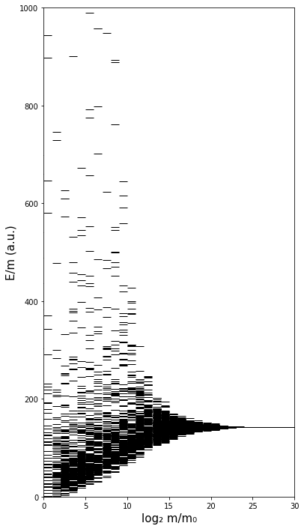

***Figure 6****.* Illustration of the stochastic nature of energy lost by single particles of identical energies traversing targets of varying mass. The density of lines provides a qualitative representation of the probability of events of energy loss per unit mass and then, an indirect indication of the distribution spread. As the target mass increases from left to right, the distribution narrows, indicating reduced variability and convergence toward a nearly constant value of energy per unit of mass. The figure is inspired by Rossi’s illustration [Rossi 1968] often used to illustrate the stochastic nature of energy deposition in target of different masses.

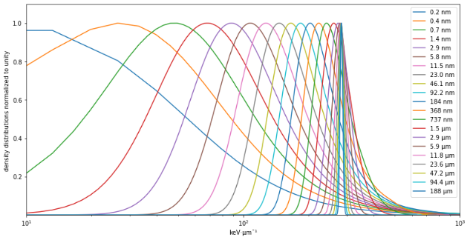

***Figure 7***. Density distribution of energy loss per unit of length for 25 MeV·u-1 carbon ions in silicon. The targets’ thicknesses progressively increasing of a factor 2 from 0.2 nm to 188 µm. The distributions are normalized to have a unitary maximum and extend beyond the upper limit of the horizontal axis.

1. **References**

[Brenner 1998] Brenner DJ, Zaider M., Letters to the editor: Estimating RBEs at clinical doses from microdosimetric spectra. Medical Physics. 1998; 25(6):1055-7.

[Fredriksson 2023] Fredriksson A, Glimelius L, Bokrantz R. The LET trilemma: conflicts between robust target coverage, uniform dose, and dose‐averaged LET in carbon therapy. Medical Physics. 2023 Dec;50(12):7338-48.

[Inaniwa 2010] Inaniwa T, Furukawa T, Kase Y, Matsufuji N, Toshito T, Matsumoto Y, et al., Treatment planning for a scanned carbon beam with a modified microdosimetric kinetic model. Phys Med Biol 2010;55:6721–37. <https://doi.org/10.1088/0031-9155/55/22/008>

[Hagiwara 2019] Hagiwara Y, Bhattacharyya T, Matsufuji N, et al. Influence of dose-averaged linear energy transfer on tumour control after carbon-ion radiation therapy for pancreatic cancer. Clin Transl Radiat Oncol 2019;21:19–24. <https://doi.org/10.1016/j.ctro.2019.11.002>.

[Hawkins 1994] Hawkins R. A statistical theory of cell killing by radiation of varying linear energy transfer. Radiat Res 1994;140:366–74. https://doi.org/10.2307/3579114.

[Kellerer 1972] Kellerer AM. An algorithm for LET-analysis. Physics in Medicine & Biology. 1972 Mar 1;17(2):232.

[Kellerer 1985] Kellerer AM, Fundamentals of microdosimetry, Chapter in ‘The dosimetry of ionizing radiation: Volume I’, Kase KR, Bjärngard BE, Attix FH Editors, Academic Press, Inc. Harcourt Brace Jovanovich, Publishers, 1985

[Loncol 1994] Loncol T, Cosgrove V, Denis JM, Gueulette J, Mazal A, Menzel HG, Pihet P, Sabattier R. Radiobiological effectiveness of radiation beams with broad LET spectra: microdosimetric analysis using biological weighting functions. Radiation Protection Dosimetry. 1994 Apr 1;52(1-4):347-52., <https://doi.org/10.1093/oxfordjournals.rpd.a082212>

[Magrin 2018] Magrin G. A method to convert spectra from slab microdosimeters in therapeutic ion-beams to the spectra referring to microdosimeters of different shapes and material. Physics in Medicine & Biology. 2018 Oct 29;63(21):215021.

[Matsumoto 2020] Matsumoto S, Lee SH, Imai R, et al. Unresectable chondrosarcomas treated with carbon ion radiotherapy: relationship between dose-averaged linear energy transfer and local recurrence. Anticancer Res 2020;40:6429–35. <https://doi.org/10.21873/anticanres.14664>.

[Molinelli 2021] Molinelli S, Magro G, Mairani A, et al. How LEM-based RBE and dose-averaged LET affected clinical outcomes of sacral chordoma patients treated with carbon ion radiotherapy. Radiother Oncol 2021;163:209–14. https://doi.org/10.1016/j.radonc.2021.08.024.

[A.Parisi 2020] Parisi A, Sato T, Matsuya Y, Kase Y, Magrin G, Verona C, Tran L, Rosenfeld A, Bianchi A, Olko P, Struelens L. Development of a new microdosimetric biological weighting function for the RBE10 assessment in case of the V79 cell line exposed to ions from 1H to 238U. Physics in Medicine & Biology. 2020 Dec 2;65(23):235010.

[G.Parisi 2025] Experimental and computational characterisation of the secondary fragment field in clinical proton therapy beams using microdosimetry, 3rd International Workshop on Microdosimetry for Particle Therapy: Bridging physics and biology, Buenos Aires, Argentina, 3rd June 2025

[Pihet 1999] Pihet P, Menzel HG, Letters to the editor: Response to the Letter to the Editor “Estimating RBEs at clinical doses from microdosimetric spectra”, Medical Physics. 1999; 26(5):848-52

[Rossi 1968] Rossi HH. Microscopic energy distribution in irradiated matter. Radiation dosimetry. 1968 Jan 1;1:43-92.

1. **Internal file surces**

Figure 6: [Source: Python notebook —Energy_straggling_convolutions-FFT-26Aug2025-Rossi_graph-4publishing]

Figure 7: [Source: Python notebook —Energy_straggling_convolutions-FFT-26Aug2025-Rossi_graph-4publishing]

|  |  |  |  |
| --- | --- | --- | --- |
| Chapter GREEN | | | |
| **Version** | **Date** | **Authors** | **Major changes and comments** |
| 1.0 | 10 Sept 2025 | Giulio Magrin, Hugo Palmans | First version |
|  |  |  |  |
| **Intellectual Property (IP) Statement:**  *"This document is the result of collaborative research conducted by the undersigned authors. All intellectual property rights associated with the content herein remain with MedAustron and the respective institutions of the contributing authors, and any use, reproduction, or distribution must be authorized by those institutions”* | | | |